
Motor Insurance Pure Premium Prediction
— An Interpretable Neural Additive Model Based on Multi-Task Learning

ABSTRACT

Motor insurance pure premium prediction is a fundamental task in non-life insurance ratemaking, with direct relevance to tariff setting, risk segmentation, and regulatory communication. Generalized linear models (GLMs) have long been widely adopted in actuarial pricing because of their robustness and interpretability. However, their predictive performance is often limited when applied to motor insurance data, which typically exhibit zero-inflation, heavy-tailed loss distributions, and complex nonlinear and interaction effects. Although modern statistical learning methods, particularly machine learning and deep learning models, can substantially improve predictive accuracy, their black-box nature often poses challenges for model transparency, stability, and regulatory compliance. To address the trade-off between predictive performance and interpretability, this study applies a Multi-Task Learning Neural Additive Model (MTL-NAM) to motor insurance pure premium prediction. The proposed model retains an additive structure to preserve interpretability, while employing neural networks to flexibly capture nonlinear feature effects. Furthermore, by jointly modeling claim frequency and claim severity within a multi-task learning framework, it implicitly accounts for their potential dependence and provides a unified representation of the pure premium formation process. Empirical analysis is conducted using the French motor third-party liability dataset freMTPL from CAS Datasets. Multiple benchmark models are implemented for comparative evaluation of predictive performance, together with an assessment of model interpretability. The results show that, under the data setting and evaluation framework of this study, MTL-NAM improves pure premium prediction while retaining auditable explanatory outputs, offering a reproducible technical paradigm and practical reference for interpretable machine-learning-based ratemaking in non-life insurance.
KEYWORDS：motor insurance pricing pure premium prediction neural additive model multi-task learning interpretable machine learning

TABLE OF CONTENTS

I. Introduction 1
(I) Research Background 1
(II) Research Objectives and Significance 2
(III) Research Content and Methods 3
II. Literature Review 4
(I) Extensions and Modifications of Traditional Models 4
(II) The Introduction of Machine Learning and the “Black-Box” Dilemma 5
(III) Modeling Dependence Between Claim Frequency and Severity 6
(IV) Multi-Task Learning Framework and Its Motivation for Pure Premium Modeling 6
III. Research Hypotheses and Model Specification 7
(I) Research Hypotheses 7
(II) Model Construction 9
(III) Model Evaluation 19
(IV) Model Interpretability 20
IV. Pure Premium Prediction 22
(I) Data Sources 22
(II) Analysis of Model Training Results 28
V. Conclusions and Future Research 35
(I) Research Conclusions 35
(II) Research Limitations 36
(III) Future Research 38
References 40
Statement of Originality for Undergraduate Thesis (Design) 42
Authorization for Use of the Undergraduate Thesis (Design) 42
Acknowledgements 43

Motor Insurance Pure Premium Prediction — An Interpretable Neural Additive Model Based on Multi-Task Learning

I. Introduction

(I) Research Background
Motor insurance is currently the largest line of non-life insurance business in China. In 2024, motor insurance premiums exceeded RMB 913 billion, accounting for more than 54% of total non-life premium income. The number of registered vehicles increased from 336 million in December 2023 to approximately 353 million in December 2024. In recent years, China’s motor insurance market has also been affected by the 2020 motor insurance reform and the COVID-19 pandemic, which reduced both premiums and loss ratios. These developments make prudent and actuarially sound pricing especially important. As shown in Figure 1, motor insurance premium income generally increased from 2014 to 2024, indicating continued market expansion; meanwhile, the combined ratio repeatedly fluctuated around the break-even level. This divergence between market growth and underwriting profitability highlights the importance of rational pricing and improved underwriting margins in motor insurance.

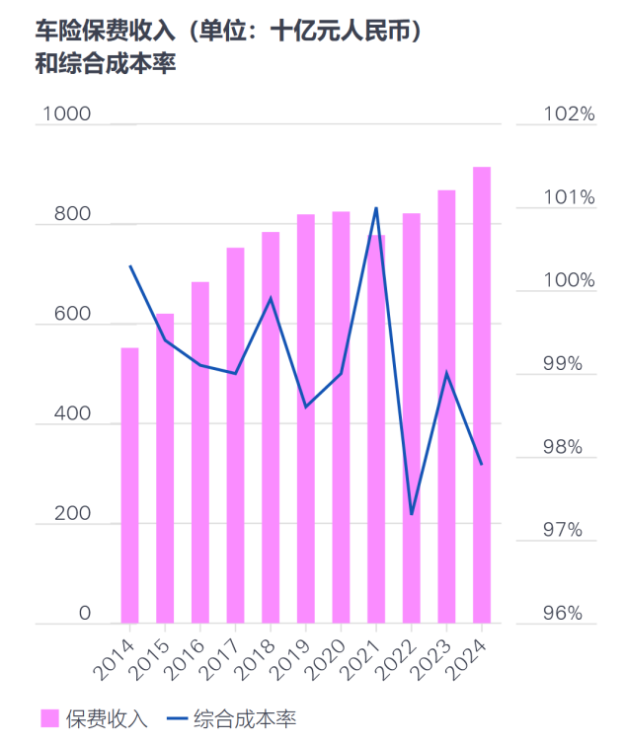
Figure 1. Trends in China’s Motor Insurance Premium Income and Combined Ratio, 2014–2024
Source: National Financial Regulatory Administration

In motor insurance pricing and business management, pure premium predictions directly affect tariff setting, risk segmentation, solvency management, anti-money-laundering controls, and regulatory compliance. From a theoretical perspective, pure premium prediction is a central problem in actuarial science and fundamentally involves the joint modeling of claim frequency and claim amount. Current academic and industry research on motor insurance pure premium prediction largely follows two directions: traditional actuarial modeling based on GLMs or their extensions, and modern black-box statistical learning methods aimed at improving predictive performance. By comparison, relatively few studies systematically combine multi-task learning with structurally interpretable models in an actuarial motor-pricing setting. Research on shared multi-task architectures, interpretability analysis, and the balance between predictive performance and transparency remains limited. In practice, insurers therefore continue to face a difficult trade-off between model performance and interpretability when adopting complex machine-learning models.

(II) Research Objectives and Significance

1. Research Objectives
This thesis studies motor insurance pure premium pricing and aims to construct a modeling framework that balances predictive performance and interpretability, and to evaluate it systematically on real motor insurance data. Starting from the formation mechanism of pure premium, the study unifies its modeling objectives and evaluation criteria around the relationship among claim frequency, claim severity, and pure premium. It explicitly specifies the data construction procedure, training–validation split, and evaluation metrics to support fairer model comparison and improve reproducibility.
Building on this framework, the thesis applies a Multi-Task Learning Neural Additive Model (MTL-NAM) to pure premium prediction by jointly predicting claim frequency and claim severity. The shared network layers are intended to uncover potential common structure between the two tasks, thereby improving overall pure premium prediction and model generalization. The study also emphasizes interpretability and auditability. Traditional generalized linear models (GLMs) can be limited when handling zero inflation, heavy tails, nonlinearities, and interaction effects, whereas high-performing black-box models may raise compliance concerns because of limited transparency and robustness. The proposed model therefore seeks to capture complex relationships while still providing stable, interpretable feature effects. Finally, empirical analysis on the freMTPL dataset compares MTL-NAM with GLM/GAM approaches, ensemble-learning models, and single-task NAMs, evaluating both predictive performance and interpretability to identify the model’s strengths and limitations.

2. Research Significance
Pure premium prediction is a core problem in non-life insurance pricing, and model quality directly affects the reasonableness of tariff setting and the ability to differentiate risk. Traditional generalized-linear-model-based approaches offer strong interpretability but may have limited predictive capacity in high-dimensional and nonlinear motor insurance settings. Deep-learning models can improve predictive accuracy, but their opaque structures make it difficult to meet the interpretability requirements of actuarial pricing and regulatory compliance.
To address this tension, this study introduces neural additive models to preserve interpretability through an additive structure and then extends them within a multi-task learning framework to jointly model claim frequency and claim severity. At the structural level, the resulting approach seeks to balance predictive performance and stable explanation, helping bridge the gap between the limited expressiveness of traditional models and the opacity of black-box models.
The study aims not only to improve the accuracy of motor insurance pure premium prediction but also to provide clear marginal-effect representations of risk factors. It therefore offers a feasible path toward interpretable actuarial pricing in complex data environments, with both methodological relevance and potential for broader application.

(III) Research Content and Methods

1. Research Content
This study aims to construct a motor insurance pure premium prediction model that combines strong predictive performance with inherent interpretability and to conduct empirical analysis using the freMTPL dataset. The core idea is to integrate multi-task learning with a neural additive model so that claim frequency and claim severity can be modeled jointly in a unified and structured manner while explicitly producing nonlinear marginal effects for individual risk factors. The overall research logic follows the sequence ‘problem identification → methodological innovation → empirical validation → application of conclusions,’ as illustrated in Figure 2.

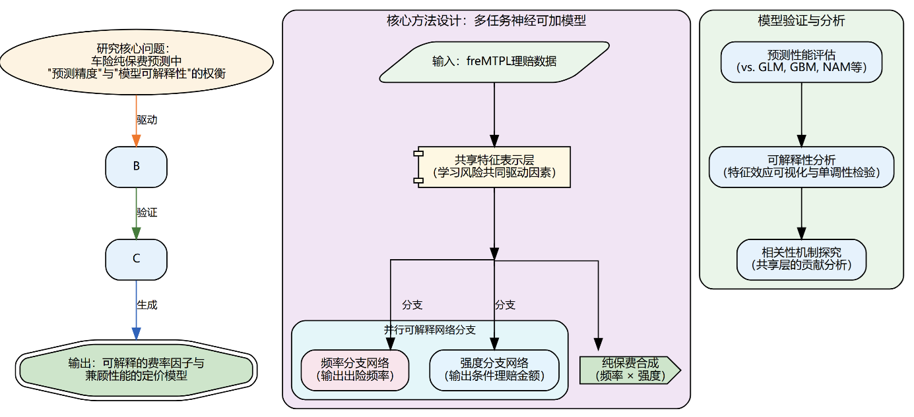
Figure 2. Research Framework

2. Research Methods
The study uses the publicly available freMTPL dataset distributed in R as the empirical data source. Neural additive models (NAMs) and their multi-task extensions have a well-established theoretical foundation and several open-source implementations, providing a sound basis for both theory and implementation. Technically, the study primarily uses mainstream machine-learning and deep-learning tools in Python, including Scikit-learn and PyTorch, together with automated machine learning (AutoML) and Bayesian tuning methods for hyperparameter optimization. Although model training is computationally intensive, the university’s high-performance computing platform and a personal GPU provide sufficient computing resources. Cross-validation and controlled benchmark experiments are adopted to improve the credibility and reproducibility of the results.
The study primarily uses experimental and comparative research methods and follows the technical workflow ‘data preparation and exploratory analysis → construction and optimization of MTL-NAM → empirical comparison and model evaluation → interpretation of results and mechanism analysis.’ Through systematic model design, training, evaluation, and interpretation, the study assesses the practical performance of MTL-NAM for motor insurance pure premium prediction.
In the experimental component, an MTL-NAM is constructed and applied to real insurance data. The central hypothesis is that a multi-task learning framework can improve overall pure premium prediction by implicitly capturing relationships between claim frequency and claim severity while preserving interpretability. MTL-NAM is therefore treated as the experimental model, with corresponding benchmarks trained under the same data conditions. Prediction errors, loss values, and feature-effect plots are recorded systematically to test the hypothesis. If the empirical results do not support the initial expectations, the hypothesis is revised accordingly. The workflow proceeds through model construction, training, and hyperparameter optimization.
In the comparative component, MTL-NAM is compared with traditional benchmark models. Model performance is evaluated comprehensively in terms of interpretability, robustness, predictive accuracy, and loss behavior.

II. Literature Review

(I) Extensions and Modifications of Traditional Models
In non-life insurance pricing, pure premium is typically defined as the expected loss cost conditional on a set of risk characteristics and can be decomposed into the product of claim frequency and claim severity. Its estimation depends on statistical models that integrate all available information about risk. Technical ratemaking aims to estimate each policyholder’s pure premium as accurately as possible using regression techniques. In property and casualty insurance, expected loss is traditionally estimated by modeling claim frequency and severity separately as functions of policy and policyholder characteristics. Nelder and Wedderburn (1972) introduced the generalized linear model (GLM), which subsequently became a foundational tool in non-life insurance ratemaking because it can accommodate key data features while retaining strong interpretability. Meng Shengwang (2007) further established the standard role of GLMs in classification ratemaking and addressed limitations of traditional univariate approaches in handling interaction effects and negative fitted values.
For heterogeneous, zero-inflated, and heavy-tailed motor insurance data, a standard GLM may be misspecified in both its distributional assumptions and linear structure, limiting robustness and predictive accuracy. Subsequent research has therefore focused mainly on two directions: extending distributional assumptions and introducing nonparametric methods. Many studies have improved flexibility by constructing mixture-distribution models. For example, Wang Xuanhe et al. (2017, 2018) and Niu Xiaoye (2016) introduced the Generalized Beta of the Second Kind (GB2), zero-inflated negative binomial models, and the GAMLSS framework to characterize complex distributional parameters more accurately and better describe empirical claim data.
The generalized additive model (GAM), introduced by Hastie and Tibshirani (1990), extends the generalized linear model by applying unknown smooth functions to individual predictors, thereby capturing nonlinear relationships while preserving interpretability. Denuit and Lang (2004) introduced Bayesian generalized additive models (BGAMs) to incorporate spatial risk factors. Henckaerts et al. (2018) further proposed a data-driven binning algorithm based on GAM-predicted effects, improving practical usability. However, binning can introduce sensitivity to cut points and information loss, leaving questions about stability and transferability. Moreover, conventional GLM/GAM frameworks can remain overly restrictive for complex nonlinear relationships among continuous variables and may have difficulty capturing high-dimensional interactions, leaving room for improvement in non-life insurance pricing practice.

(II) The Introduction of Machine Learning and the ‘Black-Box’ Dilemma
To overcome the limitations of linear assumptions, machine-learning (ML) methods have been widely introduced into actuarial pricing. Empirical studies by Zhang Lianzeng et al. (2018), Meng Shengwang (2017), and Zhang Biyi et al. (2019) show that although GLMs are robust and easy to interpret, they are constrained by distributional assumptions and linear structures. Neural networks, random forests, XGBoost, and related ensemble methods can achieve substantially stronger predictive accuracy and can also identify variable importance. Delong et al. (2021) further proposed mixture density networks (MDNs), combining neural networks with mixture distributions to capture multimodality.
Despite improved predictive performance, the adoption of machine learning creates two major challenges: limited interpretability and a high barrier to practical implementation. First, machine-learning model development often depends heavily on expert feature engineering, data preprocessing, model selection, and hyperparameter tuning. Dong and Quan (2025) introduced automated machine learning (AutoML) into insurance pricing to reduce this implementation burden, but AutoML does not eliminate the underlying black-box nature of many models and therefore does not fully resolve transparency and interpretability concerns. Second, machine-learning and deep-learning models such as neural networks are often treated as black boxes whose internal decision mechanisms are not transparent, making their outputs difficult to explain and potentially incompatible with the stringent regulatory and compliance requirements of the insurance industry. Zhang Lianzeng (2018), for example, noted that regression trees can produce stepwise predictions that lack smoothness and transparent functional forms.
As machine learning has become more widely used in actuarial science, interpretability research for complex predictive models has become an important area of study. Two main approaches have emerged. The first is model-agnostic post-hoc explanation. Friedman (2009), for example, introduced partial dependence plots (PDPs) to characterize feature effects, while Apley and Zhu (2020) proposed accumulated local effects (ALE) to reduce estimation bias arising from correlated features. SHAP, introduced by Lundberg and Lee (2017), and LIME, proposed by Ribeiro et al. (2016), have also been widely used in insurance fraud detection and risk pricing. Although these methods offer insight into black-box models, post-hoc explanations can be unstable and difficult to translate directly into tariff structures in tasks such as motor insurance pricing, where regulators may require strong model transparency and monotonicity. The second approach is to construct inherently interpretable models such as Neural Additive Models (NAMs). Agarwal et al. (2021) proposed NAMs, which combine the expressive power of deep neural networks with the interpretability of additive models and provide accurate, interpretable machine-learning solutions for high-stakes decision settings. Their differentiability and composability also make them suitable for extensions such as multi-task learning. Building on this line of work, Laub et al. (2025) developed an interpretability framework for insurance pricing and proposed an Actuarial Neural Additive Model (ANAM) designed to handle multiple data types while balancing interpretability with predictive accuracy. However, that model does not examine multi-task learning in insurance pricing, where shared parameters may improve generalization.

(III) Modeling Dependence Between Claim Frequency and Severity
Empirical insurance data may exhibit dependence between claim counts and claim amounts. Traditional approaches, including frequency–severity models and compound-Poisson Tweedie models, often rely on conditional independence assumptions; if these assumptions are violated, estimates and predictive distributions may be distorted. Shi et al. (2015) addressed such dependence using conditional variables and compound copula functions, improving predictive accuracy and risk management.
In the existing ANAM framework, frequency and severity are analyzed as separate subproblems. Under a multi-task ANAM-style framework, however, shared representations or hidden layers can learn common risk drivers that affect both tasks, thereby providing an implicit representation of potential dependence. Such a mechanism may improve coordination between frequency and severity predictions and strengthen overall consistency and robustness.

(IV) Multi-Task Learning Framework and Its Motivation for Pure Premium Modeling
Multi-task learning (MTL) is an inductive-transfer framework in which multiple related tasks are trained jointly and learn shared representations, allowing transferable information across tasks to serve as an inductive bias. This can improve generalization and stabilize representation learning. Caruana (1997) systematically described the core concepts and common implementations of multi-task learning. Existing research suggests that MTL has potential applications in actuarial prediction. De Mori et al. (2025) introduced multi-task learning into life-insurance mortality forecasting, while Feng (2023) applied related ideas to non-life loss reserving. Their empirical findings indicate that multi-task learning can serve both as a mechanism for shared representation and information integration and as a source of predictive gains and modeling flexibility. These findings suggest that multi-task learning is well suited to actuarial subtasks with intrinsic relationships. Nevertheless, its application to motor insurance pure premium modeling remains limited, particularly in combination with structurally interpretable models and systematic benchmark evaluation. In motor insurance pricing, claim frequency and severity jointly determine pure premium and may be driven by some of the same risk factors. Treating them as related tasks may therefore improve generalization while producing more stable and interpretable feature-effect estimates. From this perspective, multi-task learning provides a promising technical path for pure premium modeling, and combining it with a structurally interpretable model has clear research value.

III. Research Hypotheses and Model Specification

(I) Research Hypotheses

1. Frequency–Severity Decomposition Assumption
Motor insurance pure premium pricing commonly follows a frequency–severity decomposition. This thesis begins with the conditional expectation of aggregate loss to explain why pure premium can be expressed as the product of claim frequency and claim severity. Let A denote the aggregate loss of a policy over the observation period, X the policy characteristics, and N the number of claims. By the law of iterated expectations, the expected aggregate loss conditional on X—that is, the pure premium—can be written as follows:$π(X)$

$$\begin{aligned}π(X)=E(A|X)=E[E(A|X,N)|X].\#(1)\end{aligned}$$

The pure premium studied in this thesis is therefore the conditional mean of aggregate loss given the observed risk characteristics. Consistent with this objective, the analysis focuses on estimating and predicting the conditional mean and uses this quantity to compare competing models. Because the study does not focus on uncertainty intervals for future outcomes of individual policies, prediction intervals are not constructed.
Let the payment for the k-th claim be Zₖ. Conditional on X and N, aggregate loss is the sum of claim payments and can therefore be written as:

$$\begin{aligned}E\left(A | X,N\right)=\sum_{k=1}^{N}{E\left(Zₖ | X,N\right)}.\#(2)\end{aligned}$$

The study further assumes that, conditional on X, individual claim amounts are independent and identically distributed and independent of the claim count. Therefore, for any claim k:$ZₖZₖNk$

$$\begin{aligned}E(Zₖ|X,N)=E(Zₖ|X),\#(3)\end{aligned}$$

Substituting this relationship into the preceding decomposition gives:

$$\begin{aligned}E(A|X)=E(N|X)·E(Z|X).\#(4)\end{aligned}$$

where the first term denotes the conditional claim frequency given X, and the second term denotes the conditional mean claim amount (claim severity) given X. Hence, the pure premium conditional on X can be represented as:$E(N | X)λ(X)E(Z | X)Xμ(X)π(X)$

$$\begin{aligned}π(X)=λ(X)μ(X).\#(5)\end{aligned}$$

At the policy level, further distributional assumptions are introduced. For policy i, let the feature vector, exposure, and claim count be defined as shown below. Conditional on the policy characteristics, the claim count is assumed to follow a Poisson distribution with mean determined by exposure and conditional frequency:$i xᵢ eᵢ Nᵢ xᵢ Nᵢ$

$$\begin{aligned}Nᵢ|xᵢ\sim Poisson(Λᵢ),\#(6)\end{aligned}$$
$$Λᵢ = eᵢ λ(xᵢ).$$

For policies with at least one claim, let the conditional mean claim amount be the claim severity. Conditional on the specified covariates, severity is assumed to follow a Gamma distribution:$i ZᵢNᵢ > 0 xᵢZᵢ$

$$\begin{aligned}Zᵢ|(Nᵢ>0,xᵢ)\sim Gamma(μ(xᵢ),φ).\#(7)\end{aligned}$$

where the relevant parameter denotes the dispersion parameter.$φ$
Let aggregate loss for policy i be defined as shown below. Conditional on the policy characteristics, aggregate loss is assumed to follow a Tweedie distribution:$i AᵢxᵢAᵢ$

$$\begin{aligned}Aᵢ|xᵢ \sim Tweedie(μᵢ,φ,p),\#(8)\end{aligned}$$
$$μᵢ=E(Aᵢ|xᵢ).$$

where the parameter shown denotes the conditional mean aggregate loss, with the relationship defined below.$μᵢ φ > 01 < p < 2$

2. Interpretable-Structure Assumption
In this thesis, interpretability does not require a researcher to understand every parameter in a model. Instead, the model should satisfy predefined transparency conditions so that its internal mechanisms can be described clearly. Based on this view, the thesis adopts an interpretable-structure assumption: a model for motor insurance pure premium prediction should combine strong predictive performance with sufficient transparency and analyzability. Specifically, it should make main effects and interaction effects transparent, quantify variable importance, and exhibit appropriate sparsity, monotonicity, and smoothness. These properties make the model easier to interpret and more consistent with the practical requirements of actuarial pricing.

(II) Model Construction

1. Multi-Task Linear Additive Model
Within the frequency–severity decomposition, this thesis constructs a Multi-Task Learning Neural Additive Model (MTL-NAM). Claim frequency and claim severity are treated as two related tasks, and task-specific linear predictors are built on shared feature representations. The design has two objectives: to exploit information shared between the two tasks and to use neural networks to capture nonlinear risk-factor effects while retaining an additive model structure.
For each continuous feature, an independent subnetwork is used to learn its marginal contribution to the prediction. This preserves the additive structure while allowing nonlinear effects at the feature level. Each continuous feature is modeled using a multilayer perceptron with two hidden layers and architecture 1–16–16–1.
For policy i, let the feature vector and the value of continuous feature j be defined as shown in the notation below. The batch-level notation is also defined, where the batch size is denoted accordingly.$ix_{i}={\left(x_{i1},x_{i2},…,x_{ip}\right)}^{⊤}∈R^{p}x_{ij}ijx_{j}={\left(x_{1j},x_{2j},…,x_{nj}\right)}^{⊤}∈R^{n×1}n$
Let the hidden-layer outputs, output-layer representation, weights, and bias vectors be defined as in the following notation. For continuous feature j, the forward propagation of its subnetwork is:$H∈R^{n×h}O∈R^{n×q}W^{\left(l\right)}b^{\left(l\right)}j$

$$\begin{aligned}H_{j}^{\left(1\right)}=σ\left(x_{j}W_{j}^{\left(1\right)}+1_{n}b_{j}^{\left(1\right)⊤}\right), W_{j}^{\left(1\right)}∈R^{1×16}, b_{j}^{\left(1\right)}∈R^{16},\#（9）\end{aligned}$$
$$\begin{aligned}H_{j}^{\left(2\right)}=σ\left(H_{j}^{\left(1\right)}W_{j}^{\left(2\right)}+1_{n}b_{j}^{\left(2\right)⊤}\right), W_{j}^{\left(2\right)}∈R^{16×16}, b_{j}^{\left(2\right)}∈R^{16},\#（10）\end{aligned}$$
$$\begin{aligned}O_{j}=f_{j}\left(x_{j}\right)=H_{j}^{\left(2\right)}W_{j}^{\left(3\right)}+1_{n}b_{j}^{\left(3\right)}, W_{j}^{\left(3\right)}∈R^{16×1}, b_{j}^{\left(3\right)}∈R.\#（11）\end{aligned}$$

where the activation function is ReLU; the intermediate terms denote the outputs of the first and second hidden layers; and the final term is the shape-function output for feature j. A shape function represents the contribution of a feature to the model output and describes how changes in that feature affect the additive predictor. Because each continuous feature is assigned its own subnetwork, the model can learn feature-specific nonlinear effects while retaining overall interpretability.$σ\left(⋅\right)H_{j}^{\left(1\right)}H_{j}^{\left(2\right)}O_{j}j$

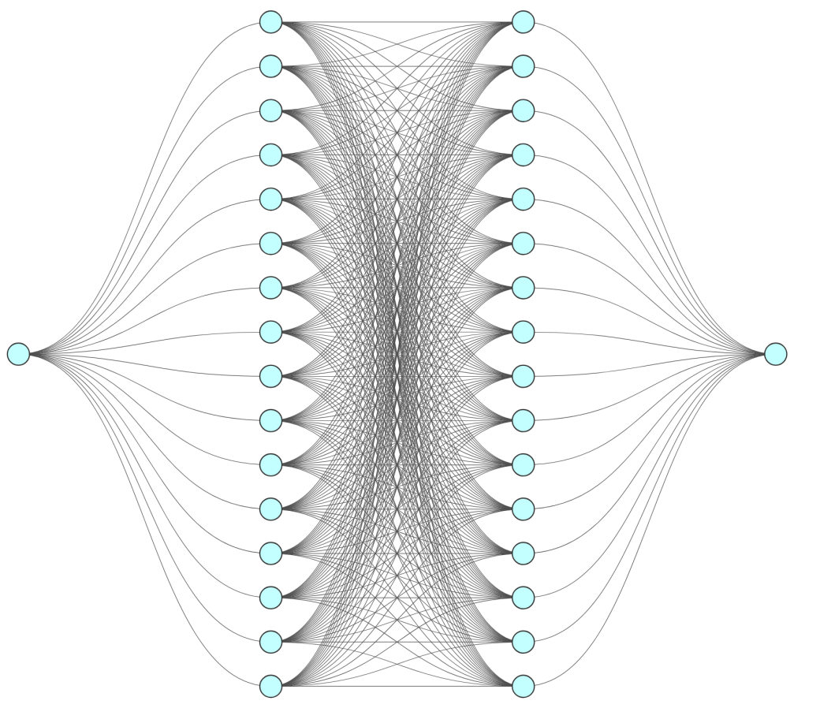
Figure 3. Architecture of the Continuous-Feature Subnetwork

For categorical features, some variables contain many levels. Direct one-hot encoding can therefore lead to rapid dimensional expansion, excessive parameter counts, and unstable training. Instead of using linear coefficients on one-hot indicators, this study first maps each category to a low-dimensional dense vector through an embedding layer. The embedding allows the model to learn potential similarities among categories in a lower-dimensional space. A small subnetwork then maps the embedding to the categorical feature’s contribution to the prediction. This approach controls model size while improving the representation of categorical information. The embedding dimension is set to 4, with the computation defined below.

$$\begin{aligned}x_{j}⟶\text{Emb}\left(C_{j},4\right)⟶h_{j}\left(⋅\right)⟶f_{j}\left(x_{j}\right).\#(12)\end{aligned}$$

Figure 4. Architecture of the Categorical-Feature Subnetwork

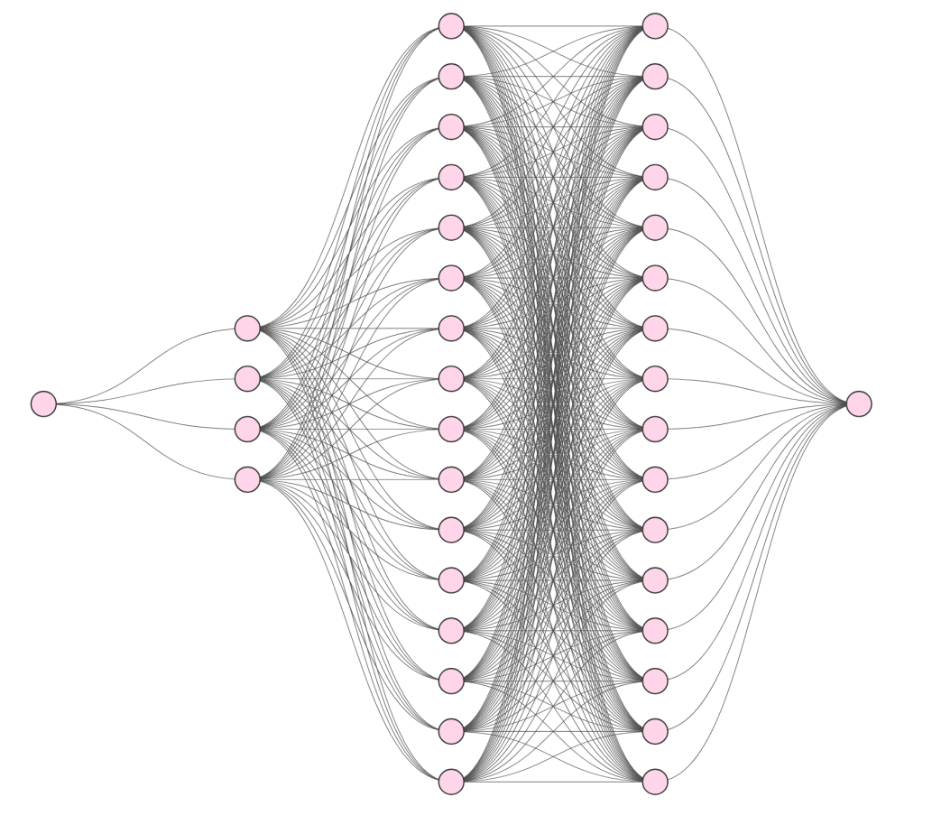
Figure 4. Architecture of the Categorical-Feature Subnetwork

After obtaining the feature-specific shape functions, separate linear predictors are constructed for the frequency and severity tasks. Each linear predictor aggregates the effects of all features before applying the link function. The two tasks share the same lower-level feature representations but use independent task-specific output weights, allowing the same feature to affect claim frequency and claim severity in different directions and magnitudes. The frequency and severity linear predictors are written as follows:$η_{f}(·)η_{s}(·)$

$$\begin{aligned}η_{f}\left(x_{i}\right)=β_{f}+\sum_{j=1}^{p}{w_{f,j}}f_{j}\left(x_{ij}\right),\#(13)\end{aligned}$$
$$\begin{aligned}η_{s}\left(x_{i}\right)=β_{s}+\sum_{j=1}^{p}{w_{s,j}}f_{j}\left(x_{ij}\right).\#(14)\end{aligned}$$

Let the task index denote frequency and severity, respectively. The terms shown in the equations represent the feature-specific shape functions for the two tasks, the task-specific intercepts, and the task-specific weight of feature j for task t.$t∈\{f,s\}f_{j}^{\left(f\right)}\left(⋅\right)f_{j}^{\left(s\right)}\left(⋅\right)jβ_{f}{ and β}_{s}w_{t,j}$
This structure constitutes a weak-sharing multi-task architecture. The frequency and severity tasks share the same underlying feature representations to learn common information, while independent output weights allow task-specific effects. Shared shape functions capture common feature structure, whereas task-specific weights preserve differences between tasks. Consequently, a given feature may have different effect directions and magnitudes for claim frequency and claim severity. To ensure that predicted frequency and severity are always positive, both tasks use log link functions. The corresponding predictions are therefore given by:$f_{j}\left(·\right)w_{f,j}w_{s,j}$

$$\begin{aligned}\hat{λ}\left(x_{i}\right)=\exp\left(η_{f}\left(x_{i}\right)\right),\#(15)\end{aligned}$$
$$\begin{aligned}\hat{μ}\left(x_{i}\right)=\exp\left(η_{s}\left(x_{i}\right)\right).\#(16)\end{aligned}$$

The policy-level pure premium prediction is then obtained by multiplying the predicted claim frequency by the predicted claim severity:

$$\begin{aligned}\hat{π}\left(x_{i}\right)=\hat{λ}\left(x_{i}\right)\hat{μ}\left(x_{i}\right).\#(17)\end{aligned}$$

Because the frequency and severity losses can differ substantially in numerical scale, a simple equal-weighted sum may cause training to be dominated by the larger-magnitude task. To balance the two objectives, the total loss is therefore constructed as a weighted sum:

$$\begin{aligned}L=aL_{f}+\left(1-a\right)L_{s}, a∈\left[0,1\right].\#(18)\end{aligned}$$
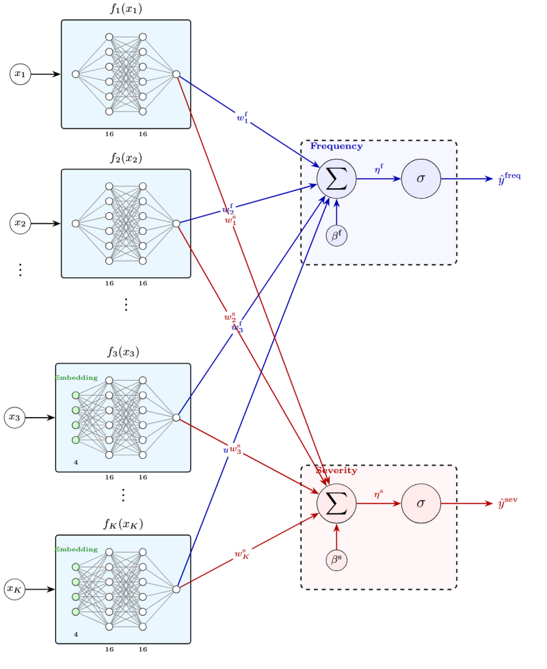
Figure 5. Architecture of the MTL-NAM Model

Note:$\hat{y^{\left(t\right)}}=σ\left(β^{\left(t\right)}+\sum_{j=1}^{K}{w_{j}^{\left(t\right)}}⋅f_{j}\left(x_{j}\right)\right), σ\left(⋅\right)=\operatorname{RELU}\left(⋅\right), t∈\{\text{freq, sev}\}, K=9$
Weakly shared subnetworks are used for continuous and categorical variables.$f_{j}:1→16→16→1f_{j}:\text{Emb}\left(C_{j},4\right)→16→16→1$

The MTL-NAM architecture is illustrated in Figure 5, and the training pseudocode is shown in Figure 6. Training consists of four steps: forward propagation, calculation of the two task losses, weighted aggregation of the joint loss, and backpropagation to update the parameters. Let the complete set of trainable parameters be denoted as shown in the notation. At each iteration, the model first performs forward propagation to compute shared shape-function representations from the input features and to obtain frequency and severity predictions. $θ$

$$\begin{aligned}s_{θ}\left(x_{i}\right)=\left(\begin{aligned}f_{1}\left(x_{i1}\right),f_{2}\left(x_{i2}\right),…,f_{p}\left(x_{ip}\right)\end{aligned}\right),\#(19)\end{aligned}$$

The task losses are then combined into the joint loss. Backpropagation is used to compute gradients of the loss with respect to all trainable parameters, and gradient-based optimization updates the parameters until the loss converges or the maximum number of iterations is reached.$\hat{λ}\left(x_{i}\right)\hat{μ}\left(x_{i}\right)L$
To reduce overfitting, the training procedure uses early stopping and L2 regularization. Parameters are updated with the Adam optimizer. The model is implemented in PyTorch, and hyperparameters are selected using grid search.


Figure 6. Pseudocode for Training the Actuarial Multi-Task Neural Additive Model

2. Benchmark Models
To evaluate the proposed MTL-NAM, three classes of benchmark models are used: the generalized linear model (GLM), representing traditional actuarial pricing; the gradient boosting machine (GBM), representing high-performance machine learning; and the neural additive model (NAM), representing interpretable neural networks. Comparing MTL-NAM with these benchmarks allows a systematic assessment of its performance in pure premium prediction.

(1) Generalized Linear Model
The generalized linear model is one of the most widely used benchmarks in non-life insurance pricing. Through a link function, a GLM connects the conditional mean of the response variable to a linear combination of predictors. Because explanatory variables enter the linear predictor additively, the model structure is transparent and its parameters are relatively easy to interpret. The general form is:

$$\begin{aligned}g\left(μ_{i}\right)=β_{0}+β_{1}x_{i1}+β_{2}x_{i2}+…+β_{p}x_{ip}.\#(20)\end{aligned}$$

where μᵢ denotes the conditional mean of the response for observation i, the link function is defined as shown, the predictor value and coefficient notation follow the equation, and the linear predictor aggregates the contributions of individual features before linking them to the conditional mean.$g(·)xᵢⱼ i j β₀、β₁、…、βₚ$
For the claim-frequency task, the policy claim count is used as the response variable and is assumed to follow a Poisson distribution. Because frequency is the expected number of claims per unit of exposure, the model must account for exposure. A log link is therefore used, with log exposure included as an offset. This specification models annualized claim frequency rather than the raw claim count observed over the policy period. The corresponding linear predictor is:$iNᵢ eᵢlog(eᵢ)$

$$\begin{aligned}η_{i}^{\left(f\right)}=g\left(Λ_{i}\right)=\log\left(e_{i}\right)+β^{\left(f\right)}+\sum_{j=1}^{p}{β_{j}^{\left(f\right)}x_{ij}}.\#(21)\end{aligned}$$

Accordingly, the annualized claim-frequency prediction for policy i is:$i$

$$\begin{aligned}\hat{λ}\left(x_{i}\right)=\frac{\hat{Λ_{i}}}{e_{i}}=\exp\left(β^{\left(N\right)}+\sum_{j=1}^{p}{β_{j}^{\left(N\right)}x_{ij}}\right).\#(22)\end{aligned}$$

For the claim-severity task, the conditional average claim amount is modeled. Because claim severity is strictly positive and claim amounts are typically right-skewed, a log link is also used for this task. The severity linear predictor is:

$$\begin{aligned}η_{i}^{\left(S\right)}=g\left(μ\left(x_{i}\right)\right)=β^{\left(S\right)}+\sum_{j=1}^{p}{β_{j}^{\left(S\right)}}x_{ij},\#(23)\end{aligned}$$

$$\begin{aligned}\hat{μ}\left(x_{i}\right)=\exp\left(β^{\left(S\right)}+\sum_{j=1}^{p}{β_{j}^{\left(S\right)}}x_{ij}\right).\#(24)\end{aligned}$$

Thus, the predicted claim severity for observation i is:$i$
Categorical variables are handled as factors following conventional actuarial modeling practice and enter the linear predictor through dummy variables. To avoid perfect multicollinearity, one category is selected as the reference level for each categorical variable, and the remaining categories are represented by indicators. This treatment yields straightforward parameter interpretation and remains consistent with traditional tariff-factor analysis.
(2) Gradient Boosting Machine
The Gradient Boosting Machine (GBM), introduced by Friedman (2001), is an ensemble-learning method that combines multiple decision trees. The model sequentially adds weak learners to correct the residuals or loss from the preceding stage, thereby improving overall predictive performance. Unlike a generalized linear model, a GBM does not impose a strict linear structure and is therefore better suited to complex nonlinear relationships among variables. Its prediction function can generally be expressed as:

$$\begin{aligned}\hat{f}\left(x\right)=\sum_{m=1}^{M}{ν} h_{m}\left(x\right).\#(25)\end{aligned}$$

where the notation represents the number of trees, the learning rate, and the m-th regression tree, respectively. As trees are added, the model iteratively adjusts the prediction function to reduce the training loss.$Mνh_{m}\left(⋅\right)m$
For comparability with the other models in this study, the GBM produces predictions on the log scale for both the frequency and severity tasks. The outputs are then exponentiated to obtain positive frequency and severity predictions. This keeps the output form consistent across the benchmark models and facilitates unified evaluation.$log(λ̂(xᵢ))log(μ̂(xᵢ))$
During training, the GBM iteratively minimizes the specified loss function. Hyperparameter tuning focuses primarily on the number of trees and tree depth, with grid search used for selection. Candidate numbers of trees range from 100 to 5,000, while candidate tree depths range from 1 to 10. Because the selected GBM implementation does not directly handle raw categorical factors, categorical variables are encoded before model fitting.
(3) Neural Additive Model
A Neural Additive Model (NAM) is an inherently interpretable neural-network model. It retains the additive structure of traditional additive models but replaces fixed linear terms with feature-specific subnetworks that learn nonlinear contributions. Because each feature is associated with an independent shape function, researchers can directly inspect how changes in a feature affect the model output. NAMs therefore combine flexible nonlinear representation with a comparatively high degree of interpretability.
In this study, NAM serves as the single-task benchmark for MTL-NAM. Separate NAMs are trained independently for claim frequency and claim severity. Their additive structure can be written as:

$$\begin{aligned}ηᵢ^{(}ᶠ^{)}= β^{\left(f\right)}+\sum_{j=1}^{p}{f_{j}^{\left(f\right)}}\left(x_{j}\right),\#(26)\end{aligned}$$
$$\begin{aligned}ηᵢ⁽ˢ⁾ = β^{\left(s\right)}+\sum_{j=1}^{p}{f_{j}^{\left(s\right)}}\left(x_{j}\right).\#(27)\end{aligned}$$

where the relevant terms denote the feature-specific shape functions for the frequency and severity tasks. Unlike the fixed linear coefficients in a GLM, these shape functions can represent more complex nonlinear relationships between predictors and responses. Log links are again used to ensure positive predictions for both tasks, yielding:$fⱼ⁽ᶠ⁾(·)fⱼ⁽ˢ⁾(·)j$

$$\begin{aligned}\hat{λ}\left(x\right)=exp\left(β^{\left(f\right)}+\sum_{j=1}^{p}{f_{j}^{\left(f\right)}}\left(x_{j}\right)\right),\#(28)\end{aligned}$$
$$\begin{aligned}\hat{μ}\left(x\right)=exp\left(β^{\left(s\right)}+\sum_{j=1}^{p}{f_{j}^{\left(s\right)}}\left(x_{j}\right)\right).\#(29)\end{aligned}$$

To ensure a fair comparison, the single-feature subnetworks in NAM use the same architecture as those in MTL-NAM. Continuous variables are modeled using lightweight multilayer perceptrons with architecture 1–16–16–1, and categorical variables are handled in the same manner as in MTL-NAM. Consequently, the primary difference between NAM and MTL-NAM is the presence or absence of multi-task parameter sharing rather than the expressive capacity of individual feature subnetworks. The NAM architecture is illustrated in Figure 7.
To strengthen interpretability, a zero-mean constraint is imposed on each shape function. This helps avoid unnecessary confounding between the intercept and individual feature contributions and facilitates comparison across feature-effect plots. The corresponding constraint is:

$$\begin{aligned}\frac{1}{n}\sum_{i=1}^{n}{f_{j}\left(x_{ij}\right)}=0, ∀j.\#(30)\end{aligned}$$

ReLU is used as the activation function. It has a simple form, provides stable training, and offers sufficient nonlinear expressive capacity. The ReLU function is:

$$\begin{aligned}ReLU\left(x\right)=max\left(x,0\right).\#(31)\end{aligned}$$

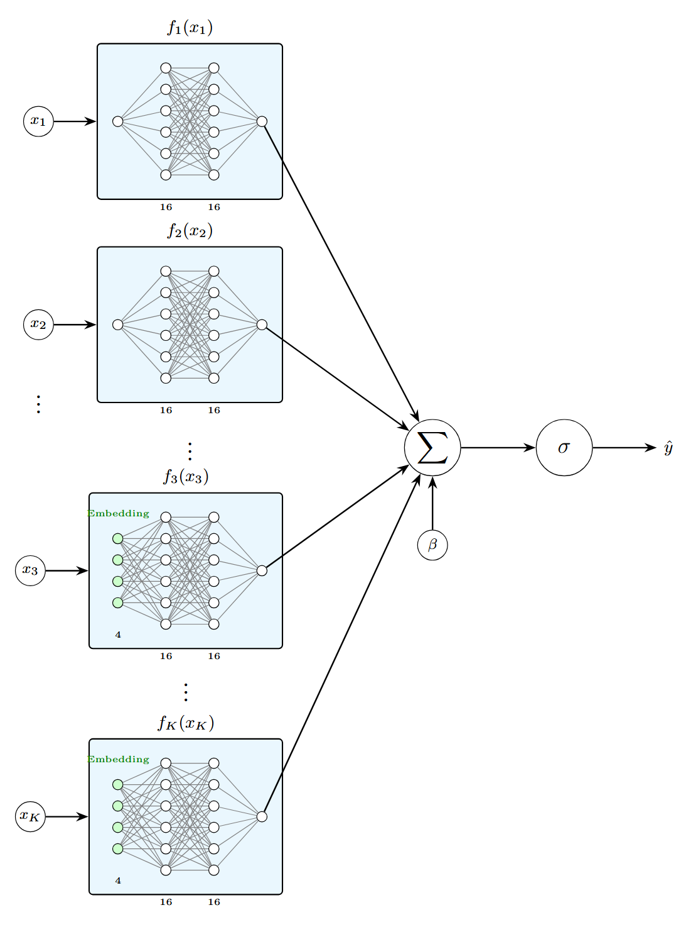
Figure 7. Architecture of the NAM Model
Note:$\hat{y}=σ\left(β+\sum_{j=1}^{K}{f_{j}\left(x_{j}\right)}\right), σ\left(⋅\right)=\exp\left(⋅\right), K=9$
Continuous variables$f_{j}:1→16→16→1$
Categorical variables$f_{j}:\text{Emb}\left(C_{j},4\right)→16→16→1$

For train–test splitting and model evaluation, this study uses six-fold cross-validation. After preprocessing, the training data are partitioned into six subsets. In each round, five subsets form the training set, while the remaining subset is held out as the test set.$DD1,…,D6l=1,…,6D_{l}$

$$\begin{aligned}D_{∖l}=\bigcup_{k≠l}{ }D_{k},\#(32)\end{aligned}$$

After fitting on the training set, each model is evaluated on the corresponding held-out fold and produces out-of-sample predictions. The predictions from all six test folds are then aggregated to obtain overall out-of-sample predictions and evaluation results for the complete sample.$D_{l}$

(III) Model Evaluation
MTL-NAM and the three benchmark model classes are evaluated using negative log-likelihood (NLL), root mean squared error (RMSE), and mean absolute error (MAE). These metrics assess performance from two perspectives: distributional fit and point-prediction error. NLL measures how well the model explains observed data under its assumed probability distribution, while RMSE and MAE measure deviations between predicted and observed values.
Negative log-likelihood (NLL) measures how well a model fits the observed data under a specified probability distribution. Lower NLL indicates better fit. It is defined as:

$$\begin{aligned}\text{NLL}=-\frac{1}{n}\sum_{i=1}^{n}{\log\left(\hat{ϕ_{i}}\left(y_{i}\right)\right)}.\#(33)\end{aligned}$$

where the term in the expression denotes the predicted density for test observation i and n is the number of test observations.$\hat{ϕ_{i}}\left(·\right)$
Root mean squared error (RMSE) measures the average magnitude of prediction error and reflects point-prediction accuracy. Lower RMSE indicates smaller predictive error. Because squared errors place greater weight on large deviations, RMSE is particularly sensitive to extreme prediction errors. It is defined as:

$$\begin{aligned}\text{RMSE}=\sqrt{\frac{1}{n}\sum_{i}{{\left(y_{i}-\hat{y_{i}}\right)}^{2}}}.\#(34)\end{aligned}$$

where the notation denotes the observed value, corresponding prediction, and number of test observations.$y_{i}i\hat{y_{i}}n$
Mean absolute error (MAE) also measures the deviation between predicted and observed values, but uses the average absolute error. Lower MAE indicates predictions closer to the observed outcomes. Compared with RMSE, MAE is less sensitive to unusually large errors and therefore more directly reflects average predictive deviation across the sample. It is defined as:

$$\begin{aligned}\text{MAE}=\frac{1}{n}\sum_{i=1}^{n}{\left|y_{i}-\hat{μ_{i}}\right|}.\#(35)\end{aligned}$$

where the notation denotes the observed value, corresponding prediction, and number of test observations.$y_{i}i\hat{y_{i}}n$

(IV) Model Interpretability
Although there is no single universally accepted definition of interpretability, Laub et al. (2025) provide a clear framework for interpretable insurance pricing models. Their framework emphasizes transparency requirements that are specific to the business context, including transparency of main effects and interaction effects, quantification of variable importance, sparsity, monotonicity, and smoothness. These criteria allow a model’s internal mechanism to be identified, analyzed, and communicated. This thesis evaluates model interpretability from the perspective of practical actuarial pricing needs.
Under the specification used in this study, the MTL-NAM pure premium model broadly satisfies the interpretability assumptions: it performs well with respect to main-effect transparency, interaction-effect transparency, quantification of variable importance, and smoothness, while satisfying sparsity and monotonicity only partially or weakly.
Main-effect transparency requires the model to clearly characterize how each individual risk factor affects claim frequency, claim severity, and ultimately pure premium. Because MTL-NAM uses an additive structure and learns a separate shape function for each feature, researchers can directly inspect the direction, magnitude, and pattern of each feature’s effect on frequency and severity predictions.
Interaction-effect transparency requires the model to state clearly whether interactions among risk factors are included and, if so, how they affect predictions. This study focuses mainly on main effects and does not explicitly include feature interactions. Accordingly, interaction transparency is achieved primarily by making this structural boundary explicit. Variable-importance quantification requires the model to measure and rank the relative contribution of individual risk factors, supporting tariff-factor selection and pricing interpretation. The study therefore supplements the structural model with feature-contribution analysis to quantify importance and further evaluate interpretability in an actuarial setting.
Sparsity means that the model should focus on a limited set of risk factors with clear business relevance and reduce the influence of redundant variables on both prediction and explanation. The current model mainly exhibits structural sparsity: it models a finite set of meaningful main effects, does not explicitly expand high-order interactions, and concentrates importance among a relatively small set of core variables. However, it does not achieve strict sparsity through explicit feature selection or sparsity-inducing regularization.
Monotonicity requires the model to identify and, where appropriate, preserve directional relationships between selected risk factors and risk levels that are consistent with actuarial knowledge, avoiding patterns that clearly contradict business logic. The current model does not impose explicit monotonicity constraints and therefore cannot guarantee monotonicity by construction. Instead, directional relationships are assessed empirically by comparing the learned shape functions with business priors, so monotonicity is only partially satisfied.
Smoothness means that predictions should change relatively gradually as continuous rating factors change, rather than exhibiting sharp fluctuations without business justification. In this study, lightweight feature subnetworks, L2 regularization, early stopping, and cross-validation are used to reduce overfitting. Continuous-feature effects are then inspected using shape-function curves and SHAP analysis. On this empirical basis, the model can be regarded as satisfying the smoothness requirement reasonably well.
Based on these interpretability requirements, the thesis analyzes MTL-NAM at two levels: inherent model interpretation and post-hoc explanation. The former uses shape functions to characterize how individual features affect predictions, while the latter uses SHAP to examine feature contributions across individual observations.
Shape functions are one of the central tools for interpreting the model. For a given feature, a shape function describes how changes in that feature alter its contribution to the model output. By inspecting these curves, the study can directly analyze how an individual predictor affects claim-frequency or claim-severity predictions. Comparing the frequency and severity shape functions for the same variable also reveals distinct pathways through which that variable contributes to pure premium. Because shape functions are visual and feature-specific, they can be compared directly with actuarial business knowledge.
In addition to the model’s inherent shape-function interpretation, SHAP is used as a supplementary post-hoc explanation method. SHAP is based on Shapley values from cooperative game theory. It treats each feature as a contributor to a prediction and decomposes the difference between an individual prediction and a baseline value into feature-level marginal contributions. For an individual observation, the additive decomposition is written as:$x$

$$\begin{aligned}\hat{y}\left(x\right)=ϕ_{0}+\sum_{j=1}^{p}{ϕ_{j}\left(x\right)},\#(36)\end{aligned}$$

where the baseline prediction and feature-level contribution are defined as shown. A positive SHAP value indicates that the feature increases the prediction for that observation, while a negative value indicates that it decreases the prediction.$ϕ_{0}ϕ_{j}\left(x\right)jxϕ_{j}\left(x\right)ϕ_{j}\left(x\right)$
The thesis further uses SHAP dependence plots and beeswarm plots to examine the distribution of feature contributions across observations and the relationship between feature values and model output. Shape-function and SHAP analyses are complementary: the former describes feature effects learned within the model structure, while the latter shows how those effects contribute to predictions at the observation level.

IV. Pure Premium Prediction

(I) Data Sources

1. Data Source
The empirical analysis uses the French motor third-party liability dataset freMTPL from CAS Datasets, distributed through R. The data are derived from anonymized records of a French motor insurer and primarily represent one-year observation periods. They contain policy-level risk factors and claim information and are widely used for comparing pure premium modeling methods in non-life insurance. The freMTPL family includes freMTPL and freMTPL2. Because freMTPL2 is substantially larger (677,991 policies) and contains richer features, it is used as the primary experimental dataset in this thesis; freMTPL may be used in future work for robustness checks or transfer-learning experiments. For modeling purposes, the data are organized into two components, freMTPL2freq and freMTPL2sev, corresponding to claim frequency and claim amounts, respectively. The data are anonymized and are commonly used in actuarial and machine-learning research, making them accessible and suitable for the purposes of this study.

Table 1. Variables in the freMTPL2freq Dataset
Variable | Type / Values | Description
IDpol | Integer ID | Policy ID
ClaimNb | Non-negative integer | Number of claims during the observation period
Exposure | Continuous in [0, 1] | Exposure (years)
VehPower | Ordered discrete value; treated as a mapped categorical variable | Vehicle power
VehAge | Continuous (years) | Vehicle age
DrivAge | Continuous (years) | Driver age
BonusMalus | Continuous (50–350); <100 = bonus, >100 = malus | Bonus–Malus coefficient
VehBrand | Categorical variable | Vehicle brand
VehGas | Categorical (Diesel / Regular) | Fuel type
Area | Categories A–F | Residential density class
Density | Continuous; persons per km² | Population density of residential area
Region | Categorical variable | French region

Table 2. Variables in the freMTPL2sev Dataset
Variable | Type / Values | Description
IDpol | Integer ID | Policy ID
ClaimAmount | Continuous (amount) | Amount paid for an individual claim

freMTPL2freq is a standard policy-level dataset containing 677,991 unique policy IDs. The freMTPL2sev dataset contains claim records for 24,944 policies, of which 1,373 policies have multiple claim payments. To construct a policy-level dataset suitable for joint frequency–severity modeling, the claim-level freMTPL2sev data are first aggregated by policy ID (IDpol) to obtain total claim amount (TotalClaimAmount) and number of claim records (ClaimCount) for each policy. The aggregated results are then left-joined to the policy-level freMTPL2freq data by IDpol. Policies without claim records are assigned a total claim amount of 0 so that frequency and severity information remain consistently aligned. This procedure creates a unified and reproducible policy-level input table for MTL-NAM training.

2. Data Preprocessing and Exploratory Data Analysis
After constructing the policy-level table, the data are preprocessed and exploratory data analysis is performed. The purpose of preprocessing is to standardize model inputs, reduce the influence of highly skewed variables on optimization, and provide a consistent basis for comparison across models.
First, observations are indexed in their original table order and assigned cyclically to six folds so that every model uses the same train–test partitions. Several continuous variables are then transformed as needed.

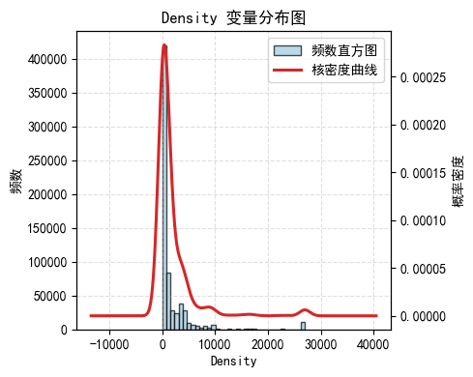
Figure 8. Distribution of Population Density

Because the population-density variable Density is strongly right-skewed and spans a wide range, a logarithmic transformation is applied to reduce the influence of extreme values and improve numerical stability. Continuous variables entering the neural models are then standardized to have mean 0 and standard deviation 1, according to the following transformation:

$$\begin{aligned}\tilde{x}=\frac{x-μ_{x}}{σ_{x}}.\#(37)\end{aligned}$$

where the terms denote the sample mean and sample standard deviation. Standardization puts continuous features on comparable numerical scales and improves the stability of neural-network optimization.$μ_{x}σ_{x}x$
Several continuous variables are discretized based on their business meaning. Driver age (DrivAge) is divided into seven groups: 0–21, 21–26, 26–30, 30–40, 40–50, 50–70, and above 70 years. This grouping helps the model identify risk differences across age segments more transparently. Vehicle age (VehAge) is also divided into intervals, with 0–1 year, 1–11 years, and above 11 years representing new, middle-aged, and older vehicles, respectively. These bins provide a more stable representation of potentially nonlinear vehicle-age effects. The resulting grouped variables are treated as categorical features in subsequent modeling.
For the severity task, the response variable Severity is constructed from policy-level total claim amount and claim count. For policies with at least one claim, TotalClaimAmount is divided by the number of claims to obtain the policy’s average claim amount, which is used as the severity response. For policies with no claims, Severity is treated as missing rather than being assigned 0. This avoids allowing zero-claim observations to distort the severity model and is consistent with the frequency–severity decomposition. For descriptive analysis and interpretability, Severity is also aggregated across combinations of categorical risk factors to compare average claim severity across risk cells.$ClaimNb>0ClaimNb$
After merging the freMTPL2 data, there are no substantive missing values other than the structural missingness of Severity for zero-claim policies described above. No additional imputation is therefore performed for the other variables.
Categorical variables are encoded according to the requirements of each model. In MTL-NAM, NAM, and GBM, categorical variables are represented through embeddings to learn potential similarities among levels. In the GLM, categorical variables are treated as factors and enter the linear predictor through dummy-variable encoding, following conventional actuarial practice.

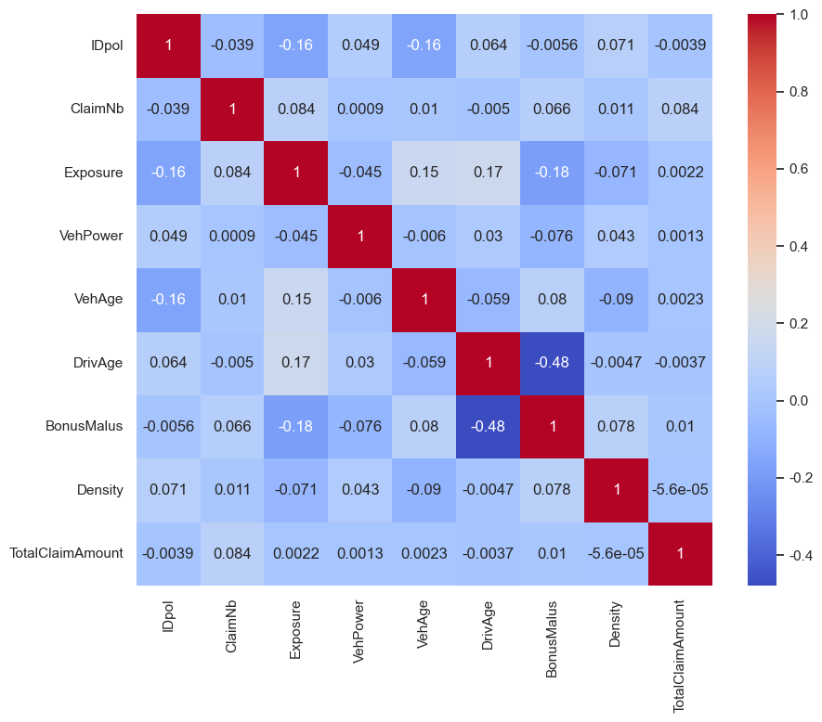
Figure 9. Pearson Correlation Heatmap of Variables

Figure 9 presents the Pearson correlation matrix for the freMTPL2 variables. Claim count (ClaimNb) and total claim amount (TotalClaimAmount) have relatively low correlation, and individual predictors exhibit little linear correlation with the response variables. The strongest linear relationship among explanatory variables is a negative correlation between driver age (DrivAge) and BonusMalus.

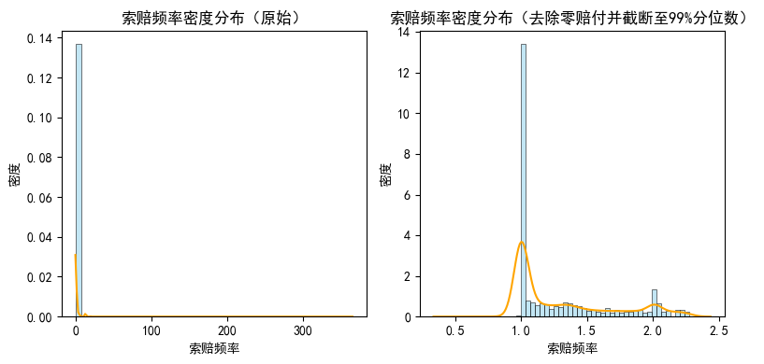
Figure 10. Distribution of Claim Frequency

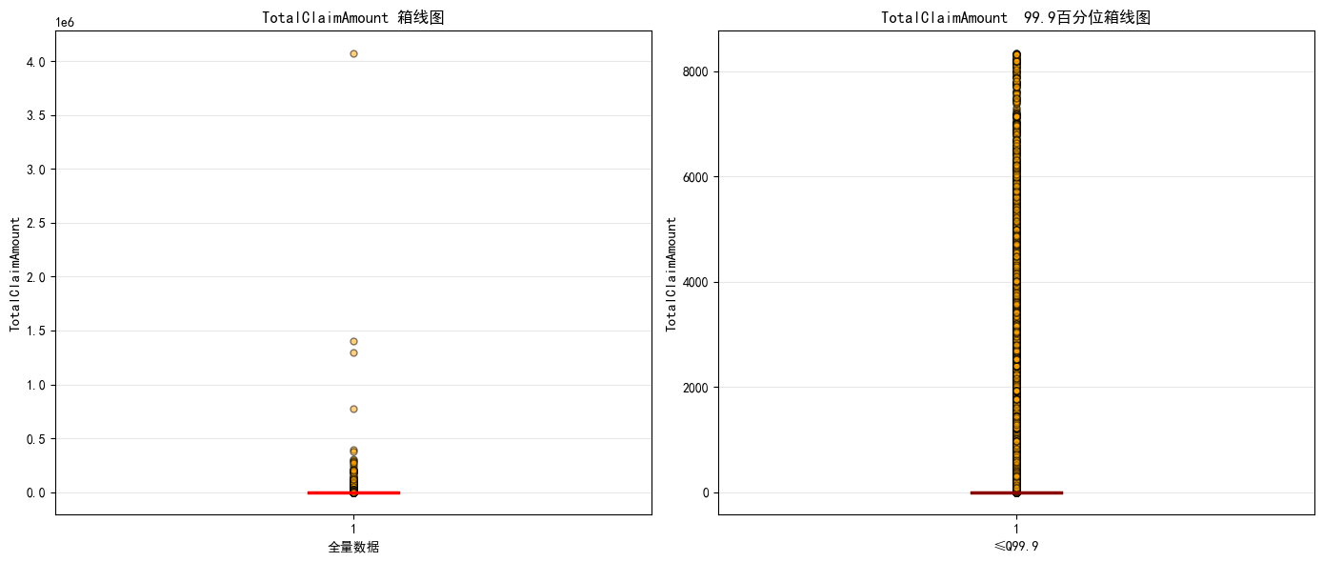
Figure 11. Boxplot of Total Claim Amount

Figure 10 shows that policy-level claim frequency is strongly concentrated near zero and exhibits a heavy tail. A log transformation makes the distribution of low-frequency policies easier to visualize. Figure 11 shows the distribution of total claim amount, including extreme losses exceeding 4,000,000. After visualization is truncated at the 99.9th percentile, the heavy-tailed structure of the main body of the distribution becomes clearer. However, extreme losses are retained during model training because they represent genuine insurance risk.

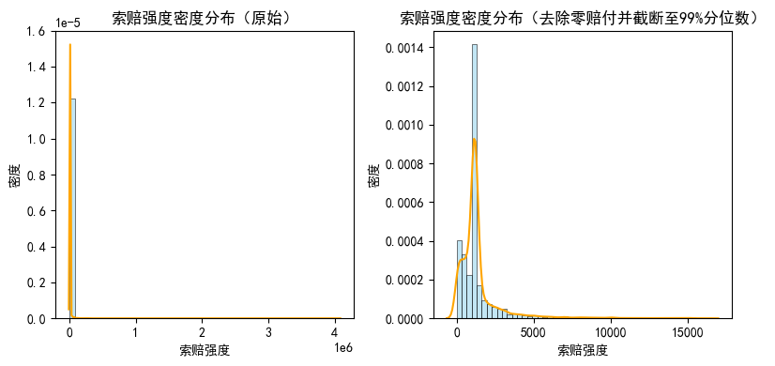
Figure 12. Distribution of Claim Severity

Figure 12 presents a histogram and kernel density estimate (KDE) of policy-level claim severity. In the original data, most claim amounts are concentrated near the lower end of the distribution, while a small number of policies have extremely large claims, producing a pronounced heavy tail. After excluding zero-claim observations and truncating the visualization at the 99th percentile, the central part of the distribution appears more symmetric.

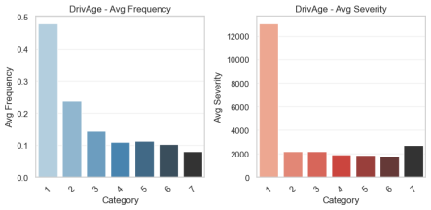 | 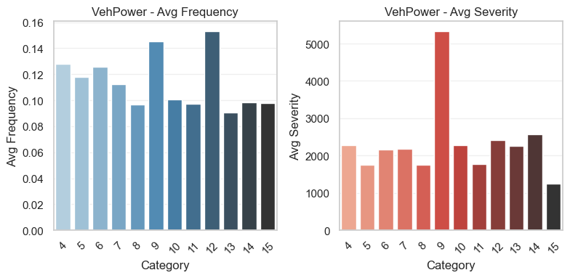
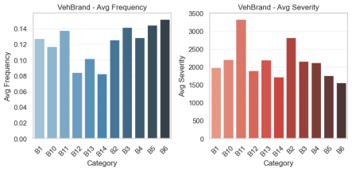 | 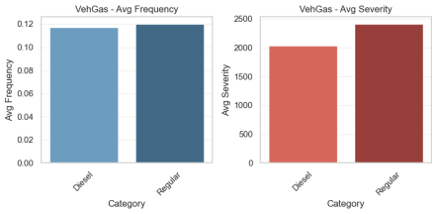 | 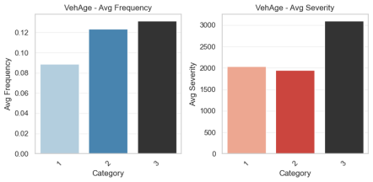
Figure 13. Average Claim Frequency and Claim Severity by Selected Risk Factors in freMTPL2

Figure 13 compares average policy-level claim frequency and severity across several key risk factors. The results show clear heterogeneity: the same risk factor can affect frequency and severity differently, indicating that the mechanisms underlying the two components of risk are not identical. For example, VehGas shows relatively small between-group differences in claim frequency but more pronounced differences in severity. Driver-age groups (DrivAge) show a broad decline in claim frequency with age, whereas differences in claim severity across age groups are more uneven. These patterns suggest that the same predictor may have different effect directions and magnitudes across the two tasks.
Several variables also exhibit non-monotonic or piecewise relationships rather than simple linear effects. For example, VehPower and VehBrand show complex between-group differences in severity, suggesting that a linear specification may be too restrictive. By contrast, VehAge shows relatively consistent risk differences across both frequency and severity, indicating that some risk factors may influence both the probability of a claim and the amount paid.
These descriptive findings provide empirical support for the frequency–severity decomposition. The risk structures associated with claim frequency and severity differ materially, and modeling them separately allows the model to capture task-specific effects while avoiding excessively strong linearity assumptions.

(II) Analysis of Model Training Results

Table 3. Test-Set Predictive Performance for Claim Frequency (Mean Across Six Folds)
 | NLL | RMSE | MAE
GLM | 0.243 | 2.018 | 0.190
GBM | 0.239 | 2.017 | 0.190
NAM | 0.156 | 2.018 | 0.189
MTL-NAM | 0.155 | 1.998 | 0.187
Note: The best value under each evaluation criterion is shown in bold; the same convention applies below.

Table 4. Test-Set Predictive Performance for Claim Severity
 | NLL | RMSE | MAE
GLM | 1.708 | 21387.021 | 2228.850
GBM | 2.759 | 21369.402 | 1708.529
NAM | 1.620 | 21320.620 | 2219.412
MTL-NAM | 1.605 | 21003.867 | 1634.039

Table 5. Claim-Frequency Predictive Performance Across the Six Data Folds
Model | Loss Function | $D$1 | $D$2 | $D$3 | $D$4 | $D$5 | $D$6 | Mean
GLM | NLL | 0.240 | 0.245 | 0.242 | 0.244 | 0.240 | 0.245 | 0.243
 | RMSE | 1.778 | 2.283 | 2.043 | 2.091 | 2.040 | 1.873 | 2.018
 | MAE | 0.178 | 0.191 | 0.193 | 0.191 | 0.194 | 0.190 | 0.190
GBM | NLL | 0.237 | 0.241 | 0.239 | 0.241 | 0.237 | 0.241 | 0.239
 | RMSE | 1.777 | 2.283 | 2.042 | 2.091 | 2.039 | 1.873 | 2.017
 | MAE | 0.178 | 0.191 | 0.193 | 0.191 | 0.194 | 0.191 | 0.190
NAM | NLL | 0.154 | 0.157 | 0.156 | 0.158 | 0.155 | 0.158 | 0.156
 | RMSE | 1.778 | 2.283 | 2.043 | 2.091 | 2.040 | 1.873 | 2.018
 | MAE | 0.178 | 0.191 | 0.193 | 0.191 | 0.193 | 0.190 | 0.189

Table 6. Claim-Severity Predictive Performance Across the Six Data Folds
Model | Loss Function | $D$1 | $D$2 | $D$3 | $D$4 | $D$5 | $D$6 | Mean
GLM | NLL | 1.595 | 1.781 | 1.875 | 1.602 | 1.893 | 1.501 | 1.708
 | RMSE | 8336.027 | 12758.556 | 15024.387 | 21592.800 | 63834.439 | 6775.913 | 21387.021
 | MAE | 2000.538 | 2084.983 | 2308.488 | 2200.608 | 2880.357 | 1898.128 | 2228.850
GBM | NLL | 2.192 | 3.019 | 2.759 | 2.544 | 3.943 | 2.095 | 2.759
 | RMSE | 8183.567 | 12832.263 | 14930.852 | 21706.736 | 63904.989 | 6658.009 | 21369.402
 | MAE | 1599.891 | 1440.610 | 1596.220 | 2031.231 | 2321.863 | 1261.358 | 1708.529
NAM | NLL | 1.469 | 1.566 | 1.818 | 1.571 | 1.897 | 1.401 | 1.620
 | RMSE | 8146.233 | 12779.734 | 14888.167 | 21655.793 | 63845.262 | 6608.533 | 21320.620
 | MAE | 2027.005 | 2106.180 | 2230.506 | 2210.389 | 2823.459 | 1918.936 | 2219.412
Note: NLL is a dimensionless relative measure, whereas RMSE and MAE for claim severity are absolute measures expressed in euros. Given the scale of the severity response, differences in magnitude between NLL and RMSE/MAE are expected.

Tables 3 and 4 show that the proposed MTL-NAM performs strongly in the motor insurance pure premium modeling framework. For both claim frequency and claim severity, MTL-NAM achieves the best values among GLM, GBM, NAM, and MTL-NAM on NLL, RMSE, and MAE under the evaluation definitions used in this study.
The lower NLL indicates stronger distributional fit under the study’s loss specification. Because RMSE penalizes large deviations more heavily, MTL-NAM’s advantage on this metric suggests smaller prediction errors for extreme outcomes. In insurance practice, better control of large errors may be particularly relevant to solvency management and reinsurance planning. The lower MAE indicates smaller average absolute prediction errors across ordinary policies and therefore more accurate point predictions over the bulk of the portfolio.
Tables 5 and 6 further show that the variability of MTL-NAM’s predictive loss across the six folds is comparatively low for both the frequency and severity tasks. This suggests relatively consistent performance across different subsets of the data and supports the model’s generalization and robustness within the experimental design.
These results provide empirical support for the multi-task learning framework. By sharing feature representations in the lower layers of the neural network, the model can exploit information common to the frequency and severity tasks, improving predictive performance while helping mitigate the information limitations associated with independent single-task modeling.

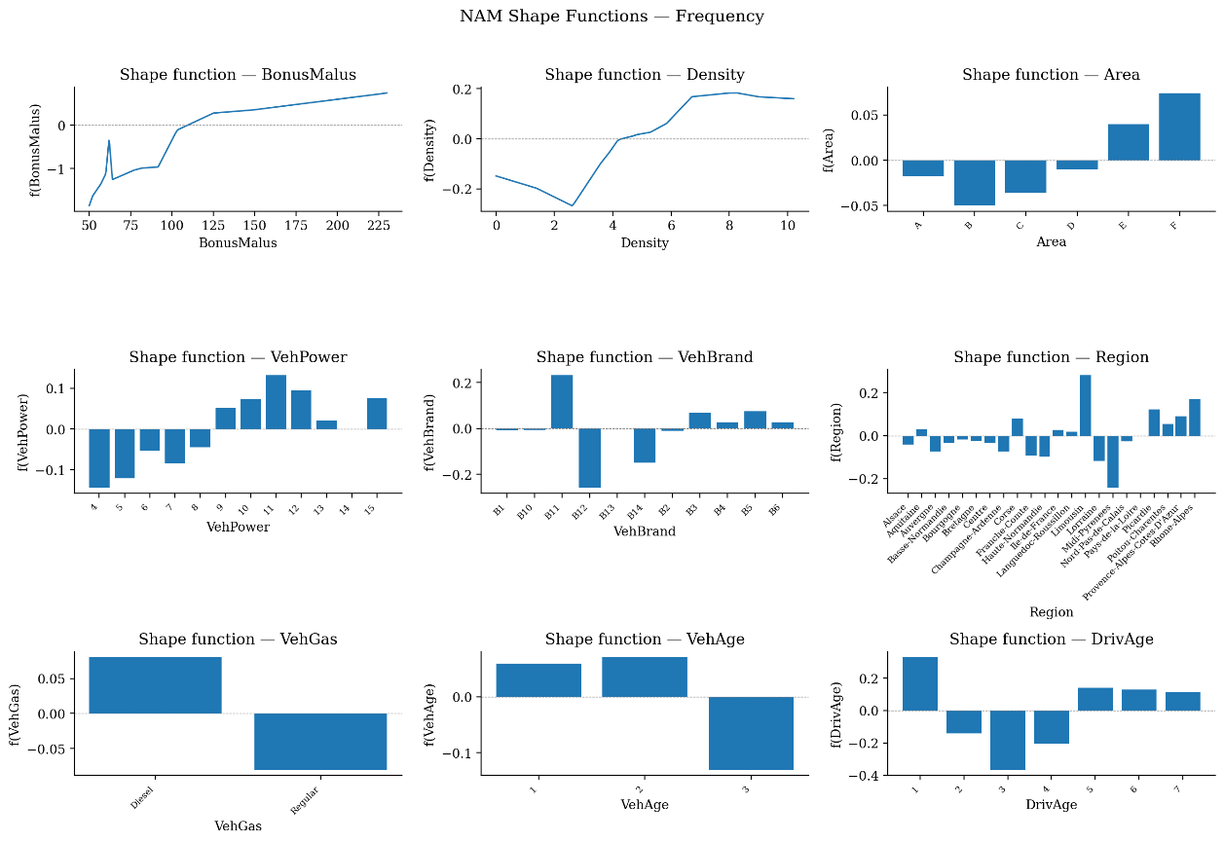
Figure 14. NAM Shape Functions for Claim-Frequency Prediction

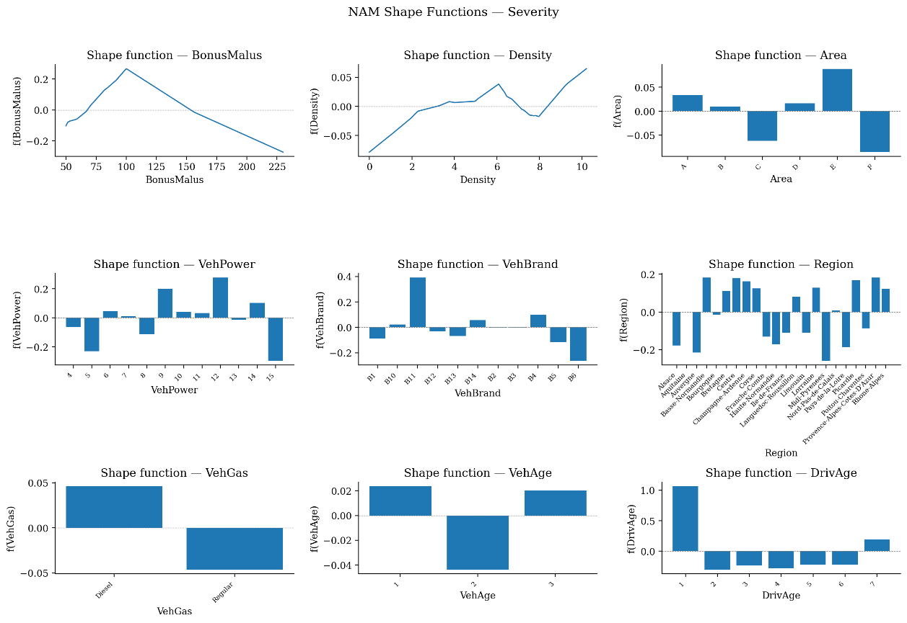
Figure 15. NAM Shape Functions for Claim-Severity Prediction

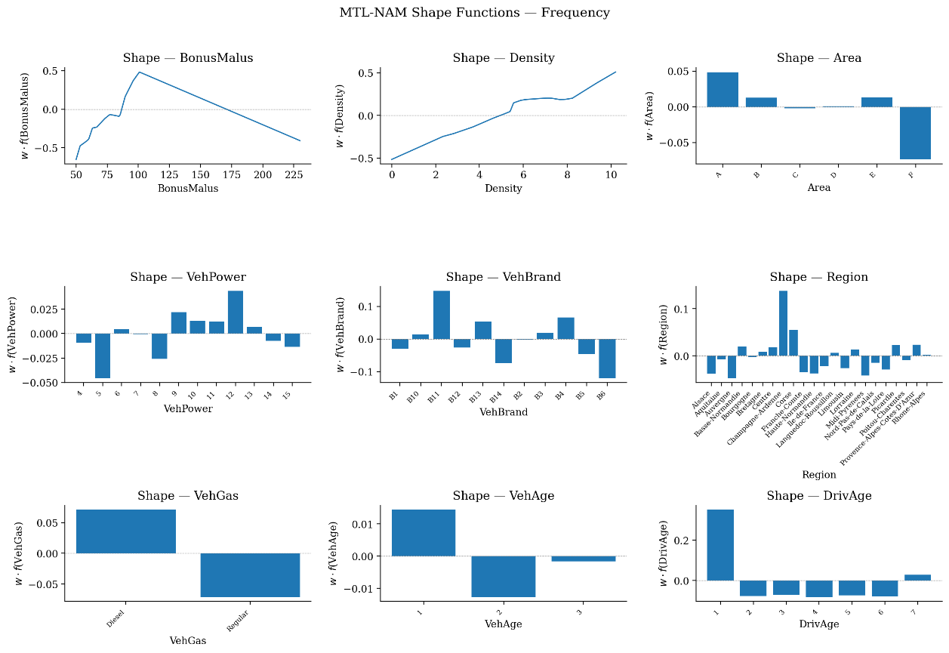
Figure 16. MTL-NAM Shape Functions for Claim-Frequency Prediction

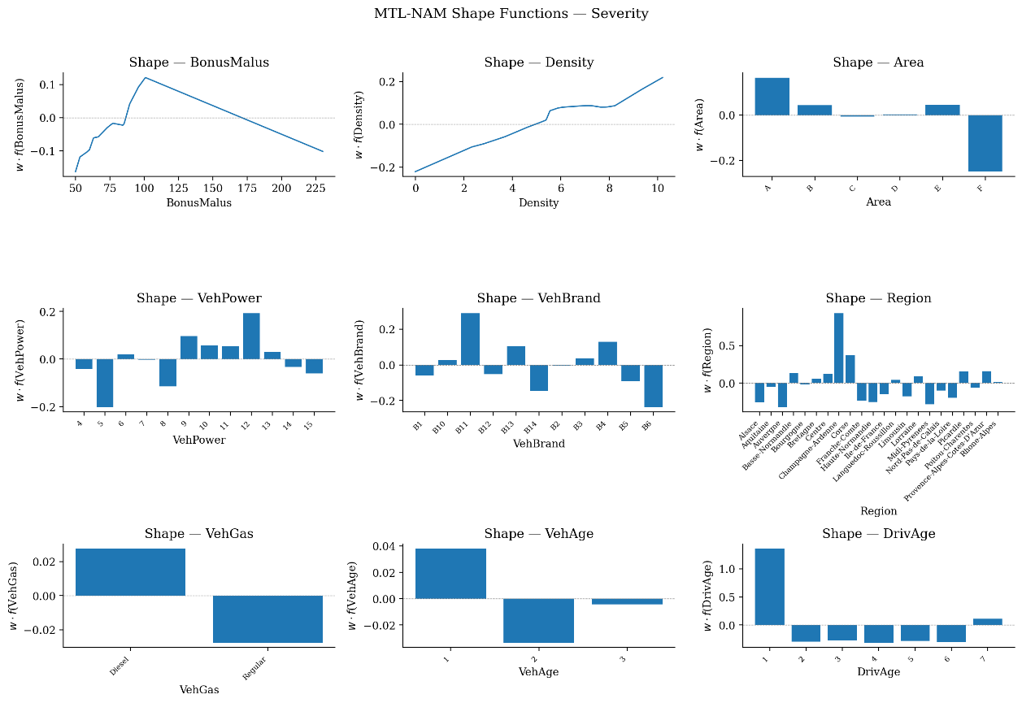
Figure 17. MTL-NAM Shape Functions for Claim-Severity Prediction

Figures 14 and 16 show that most key variables exhibit pronounced nonlinear or piecewise effects in the frequency task.
Among continuous variables, the BonusMalus shape function rises rapidly and reaches a peak around 100 before gradually declining, indicating that the relationship between this classic experience-rating factor and claim frequency is neither purely linear nor strictly monotonic. Instead, the pattern can be described as high sensitivity at lower values, a peak in the middle range, and diminishing or declining marginal effects at higher values. This piecewise structure provides direct empirical motivation for replacing a GLM’s linear term with a neural feature subnetwork. The shape function for Density is broadly increasing, with a mild plateau in the middle-to-high range before rising again, suggesting higher claim frequency in more densely populated and congested areas. Under the log link, this pattern implies a systematic multiplicative increase in expected frequency from low- to high-density regions rather than a simple additive change.
For categorical variables, the driver-age grouping (DrivAge) shows a distinctly asymmetric U-shaped pattern: the youngest group has a strongly positive contribution, middle-age groups are generally negative, and the oldest group rises slightly again. This is consistent with the familiar actuarial pattern of elevated risk among inexperienced drivers, lower risk among mature drivers, and some increase at advanced ages. Region and VehBrand show clear between-group heterogeneity: most levels are close to zero, but a small number of regions or brands exhibit sizeable positive or negative effects, indicating localized but meaningful variation. Area and VehGas likewise show interpretable relative differences across categories after controlling for the other covariates.
Figures 15 and 17 show that the combination of variables driving claim severity differs materially from the combination driving claim frequency, reinforcing the value of decomposing pure premium into these two components.
Driver age (DrivAge) exhibits much larger marginal contributions in the severity task: the youngest group has a strong positive effect, middle-age groups are generally negative, and the oldest group rises slightly. Region also shows substantially larger between-group differences for severity, with some regions such as Corse and Franche-Comté having positive contributions and others negative contributions. Such geographical heterogeneity may reflect differences in traffic conditions, repair costs, medical costs, regulation, or claims-handling practices. VehPower and VehBrand show clearer piecewise differences in severity, again supporting the use of nonparametric shape-function learning rather than a fixed linear specification.
Across Figures 14–17, continuous-variable curves are broadly similar in shape across the two tasks but differ markedly in scale, while the relative ordering of categorical levels is generally similar with larger dispersion in the severity task. This is consistent with the MTL-NAM design: shared subnetworks learn a common nonlinear shape for each feature, while task-specific weights rescale that shape so that the feature can differ in importance and effect magnitude across tasks. Because MTL-NAM weakly shares feature subnetworks, the underlying subnetwork shape is common across tasks; in contrast, separate NAM models learn task-specific subnetworks and can therefore produce more distinct shape functions for frequency and severity.

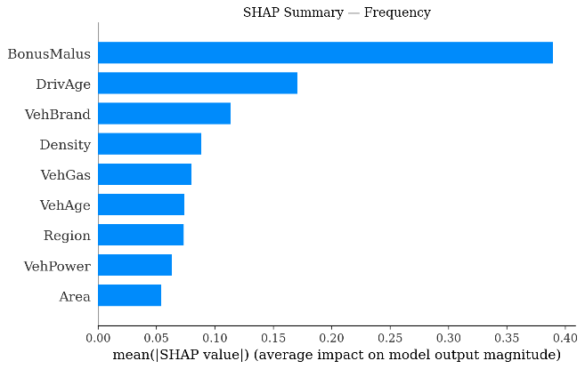 | 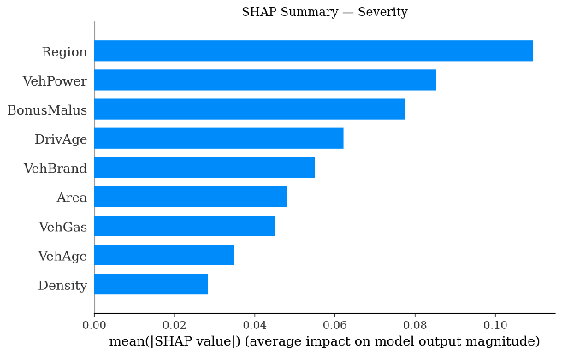
Figure 18. NAM SHAP Feature-Importance Rankings for Claim Frequency (Left) and Claim Severity (Right)

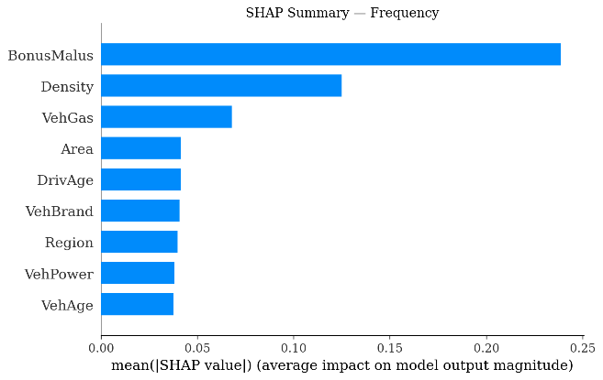 | 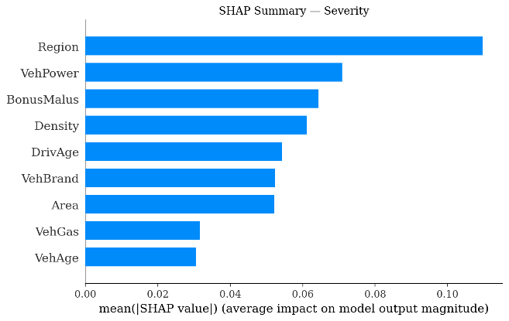
Figure 19. MTL-NAM SHAP Feature-Importance Rankings for Claim Frequency (Left) and Claim Severity (Right)

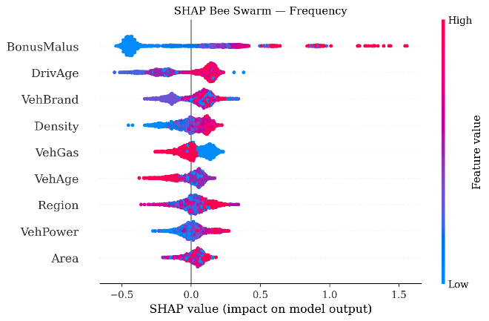 | 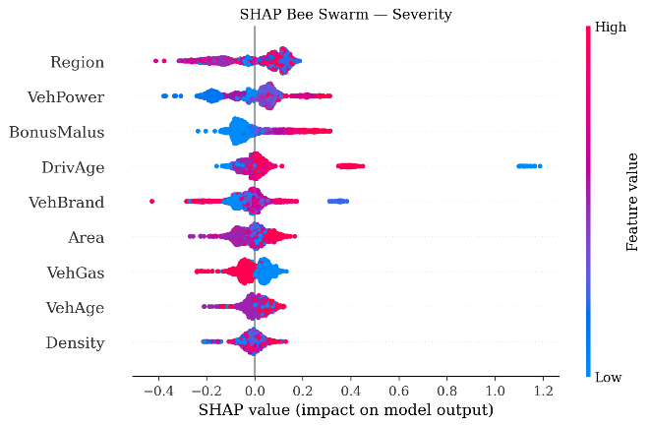
Figure 20. NAM SHAP Beeswarm Plots for Claim Frequency (Left) and Claim Severity (Right)

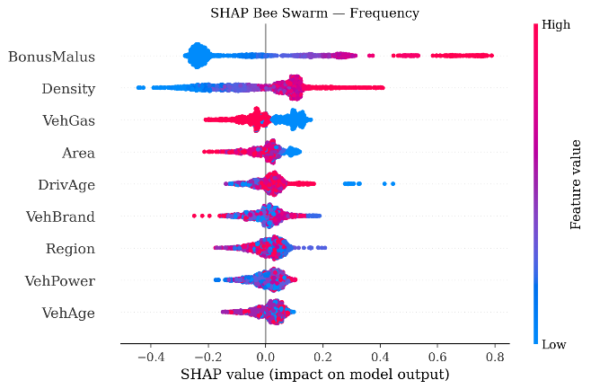 | 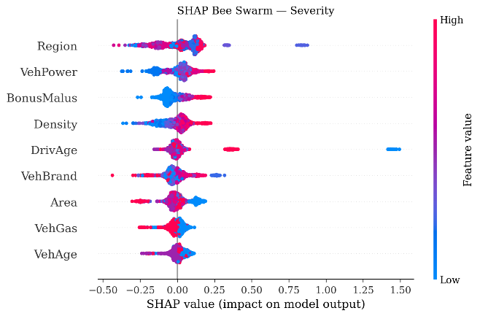
Figure 21. MTL-NAM SHAP Beeswarm Plots for Claim Frequency (Left) and Claim Severity (Right)
Note: SHAP beeswarm plots show the distribution of each feature’s contribution to model predictions.

Figure 18 further quantifies the preceding findings for the frequency task: BonusMalus and Density have substantially higher mean absolute SHAP values than the other variables and therefore dominate the frequency explanation. VehGas follows, indicating that although fuel type is binary, it has a stable and non-negligible marginal effect for some observations.
In the SHAP beeswarm plot, each point is colored according to the feature’s original value, with blue indicating lower values and red higher values. A wider horizontal spread indicates a larger effect on the model output. The direction of the patterns in Figure 20 is consistent with the shape-function analysis: higher BonusMalus values are generally associated with positive SHAP values, whereas lower values occur more often in the negative range. Density similarly shifts from predominantly negative contributions at low values to more positive contributions at high values, indicating that predicted claim frequency tends to rise with urban density.
Figures 19 and 21 show that the severity task is more sensitive to Region, VehPower, BonusMalus, Density, and related factors. In the beeswarm plot, high values of VehPower, BonusMalus, and Density tend to appear in the positive SHAP region, suggesting that higher values generally increase predicted claim severity. DrivAge includes a small number of observations with extreme positive SHAP values, corresponding to young-driver groups, but its average importance is not the largest. This suggests that its severity effect may be concentrated within a specific subgroup rather than being dominant across the entire portfolio.

V. Conclusions and Future Research

(I) Research Conclusions
This thesis addresses the central tension between predictive accuracy and model interpretability in motor insurance pure premium prediction. Based on the frequency–severity decomposition, it constructs a Multi-Task Learning Neural Additive Model (MTL-NAM) and evaluates the model on the freMTPL dataset using unified data preprocessing, six-fold cross-validation, and multiple evaluation metrics. MTL-NAM is compared systematically with GLM, GBM, and single-task NAM benchmarks. The results indicate that embedding multi-task learning within an additive neural-network structure can make fuller use of information shared between claim frequency and claim severity while preserving an additive representation and interpretable feature-level shape functions, providing a unified method with both statistical rationale and practical implementability.
In terms of predictive performance, the MTL-NAM used in this study is highly competitive and comparatively stable. Relative to traditional GLM and GBM benchmarks, it captures zero inflation, heavy tails, and nonlinear risk relationships more flexibly. Relative to single-task NAMs, the shared representation in the joint-learning framework makes better use of information across tasks, with a particularly clear improvement in the severity task and relatively low variation in loss across folds. These results suggest that multi-task learning can provide a useful inductive bias for joint frequency–severity modeling and can improve generalization and stability within the experimental setting.
The interpretability analysis shows that MTL-NAM not only improves predictive performance but also reveals the mechanisms and task heterogeneity associated with major risk factors. Shape functions and SHAP analysis identify BonusMalus, Density, DrivAge, Region, VehPower, and related variables as important drivers of motor insurance risk, while showing that their directions, magnitudes, and marginal patterns differ between frequency and severity. BonusMalus and Density are especially influential for frequency, whereas region, driver age, and vehicle characteristics show stronger differentiation in the severity task. These findings support the need to model frequency and severity separately and demonstrate the value of interpretable neural additive structures for identifying complex nonlinear risk relationships.
Overall, the thesis concludes that MTL-NAM provides a useful balance among predictive performance, interpretability, and auditability in motor insurance pure premium modeling. Methodologically, it offers a feasible response to the tension between traditional actuarial models and black-box machine-learning models and provides empirical evidence for the disciplined use of machine learning in actuarial pricing.
More broadly, this thesis asks whether a modeling framework can simultaneously deliver predictive accuracy, business interpretability, and regulatory auditability in motor insurance pricing. The empirical results suggest that MTL-NAM offers a promising answer. It depends less heavily on strict linear structures than traditional actuarial models while avoiding some of the transparency problems associated with black-box machine learning, thereby providing an intermediate approach between the two.

(II) Research Limitations
Although the proposed MTL-NAM performs well in this study and retains comparatively strong interpretability, several limitations remain and warrant further investigation.
1. Dataset Limitations
The empirical analysis uses only the freMTPL2 dataset and does not incorporate freMTPL1 or motor insurance data from other countries or regions for transfer learning and external validation. Risk-factor structures may differ materially across markets. Future research should therefore test the model on a broader range of international datasets to evaluate its generalizability and stability. Transfer-learning approaches may also help address cross-dataset differences and improve out-of-domain performance.
2. The Frequency–Severity Dependence Structure and Overall Pure Premium Evaluation Require Further Development
Following common non-life insurance practice, the study decomposes pure premium into claim frequency and claim severity and uses a multi-task architecture to capture risk information that may be shared between the two components. This keeps the model structure transparent and facilitates separate interpretation of the effects of risk factors on frequency and severity.
However, the thesis does not explicitly specify a complete joint distribution for claim count and individual claim amount. If substantial dependence remains between the two outcomes after conditioning on policy characteristics, a pure premium estimate based solely on the product of frequency and severity may be biased. The shared architecture of MTL-NAM can capture common risk information to some extent, but it is not equivalent to rigorous statistical modeling of the frequency–severity dependence structure.
In addition, the empirical evaluation focuses mainly on the predictive performance of the frequency and severity components separately and does not independently evaluate the final policy-level pure premium obtained by multiplying the two predictions. Future research should therefore add direct pure premium error metrics such as RMSE, MAE, bias ratios, or grouped calibration errors. Methodologically, copula models, joint-distribution models, or Tweedie frameworks could be incorporated to characterize frequency–severity dependence more rigorously and improve applicability to zero-inflated, heavy-tailed, and extreme-loss settings.
3. Further Development of Model Interpretability
Although the study uses a neural additive structure, shape-function visualization, and SHAP analysis to interpret predictions, the interpretability analysis remains incomplete. The current model focuses mainly on main effects and does not explicitly model feature interactions. Its treatment of sparsity, monotonicity, and smoothness is also based largely on model structure and empirical behavior rather than stronger constraints incorporated directly into the objective function or architecture. Consequently, these interpretability properties have not yet been characterized or tested under a unified and rigorous mathematical framework.
The interpretation is primarily based on the inherent transparency provided by the neural additive structure, with SHAP used only as an observation-level post-hoc analysis tool. Although post-hoc explanation methods can provide insight into black-box models, they may only approximate the model’s true reasoning process and therefore face fidelity risk. In addition, post-hoc explanations can be vulnerable to adversarial manipulation, potentially allowing underlying relationships to escape detection. In high-stakes domains such as actuarial pricing, inherently interpretable models should therefore be preferred where feasible over black-box models supplemented only with explanation techniques.
As model complexity increases, maintaining transparency for business experts and regulators while preserving predictive accuracy remains a significant challenge. In particular, more research is needed on how to quantify and optimize marginal effects and how to make shared multi-task representations more directly interpretable.
4. Robustness and Adversarial Testing
Although MTL-NAM performs well in this study, its robustness in practical applications requires further validation. Future work could inject controlled noise into the data and conduct adversarial or perturbation-based tests to assess sensitivity to abnormal observations and potential measurement error. Robustness analysis incorporating external economic variables, such as macroeconomic conditions and policy changes, could also broaden the model’s practical applicability.
5. Computational Efficiency and Challenges of Large-Scale Application
The deep-learning and multi-task architecture used in this study improves predictive capability but may create computational bottlenecks in practical deployment. As data volumes grow, future work should optimize training efficiency, reduce training time, and improve the model’s scalability for large production environments.

(III) Future Research
Motor insurance pricing is increasingly shaped by higher-dimensional data, more complex risk structures, and stronger model-governance requirements. Traditional models can be limited in their ability to represent complex relationships, whereas black-box methods face practical obstacles in pricing explanation, business communication, and model review. Developing granular pricing methods that balance predictive accuracy with interpretability has therefore become an important research direction. By combining nonlinear modeling, multi-task learning, and structural interpretability, the MTL-NAM developed in this thesis provides one possible path toward pricing models that emphasize prediction, explanation, and governance simultaneously.
A natural extension is Usage-Based Insurance (UBI), where driving-behavior data are real-time, high-dimensional, and rich in behavioral signals. These characteristics create even stronger demands on both prediction and interpretation. Future work could integrate static policy characteristics with dynamic driving-behavior data in a unified framework to improve granular pricing and dynamic risk identification.
In current non-life actuarial practice, ratemaking still relies substantially on business experience and professional judgment. Pricing methods that combine predictive accuracy with interpretability can improve both risk differentiation and rate adequacy while also supporting a gradual shift from experience-driven to data-driven pricing decisions, improving robustness, transparency, and business value.
Computing resources and efficiency also remain practical constraints. Model training and hyperparameter optimization can be time-consuming and computationally demanding, which may limit large-scale deployment in an insurer’s routine pricing workflow. Future improvements in computing power, cloud deployment, and algorithmic efficiency may gradually expand the range of applications for models of this type.
From an industry and policy perspective, the development of interpretable machine-learning pricing models also depends on stronger data infrastructure. Publicly available anonymized motor insurance datasets in China remain limited, and methodological research therefore relies heavily on overseas datasets. This restricts localized validation in the Chinese market. Subject to strict protection of personal privacy and commercial confidentiality, regulators, industry associations, universities, research institutions, and insurers could jointly promote standardized, anonymized research datasets for motor insurance, providing a stronger foundation for actuarial modeling, machine-learning pricing, and interpretability research.
From a policy perspective, the MTL-NAM framework explored in this thesis reflects a broader direction that combines granular pricing with transparent governance. As motor insurance pricing becomes more refined, regulators and insurers must evaluate not only predictive performance but also whether models can be explained, reviewed, and understood by business users. Interpretable pricing models can improve risk identification, reduce unreasonable pricing distortions, and strengthen transparency and auditability. Further development of industry data standards, model-validation standards, and interpretability criteria would support the transition from experience-driven pricing toward data-driven and governance-oriented ratemaking.

References

[1] Meng S. Application of Generalized Linear Models to Automobile Insurance Ratemaking [J]. Journal of Applied Statistics and Management, 2007(1): 24–29. (in Chinese)
[2] Meng S, Li T, Gao G. Prediction of Motor Insurance Claim Probability and Aggregate Claims Using Machine-Learning Algorithms [J]. Insurance Studies, 2017(10): 42–53. (in Chinese)
[3] Niu X. Motor Insurance Ratemaking Based on Generalized Linear Models [J]. China Insurance, 2016(10): 7–12. (in Chinese)
[4] Wang B, Tang J, Kan R. China Motor Insurance Market Report [EB/OL]. Swiss Re China, https://www.swissre.com/china/news-insights/articles/china-motor-insurance-report.html, 2025-08-26.
, 2025-08-26.
[5] Wang X, Meng S, Wang Y. Automobile Insurance Pricing Models Based on Heavy-Tailed Loss Distributions and Their Applications [J]. Insurance Studies, 2017(4): 67–78. (in Chinese)
[6] Wang X, Meng S, Yang M. Extensions and Applications of Models for Motor Insurance Claim Counts [J]. Insurance Studies, 2018(11): 82–92. (in Chinese)
[7] Zhang B, Xiao Y, Zeng Y. A Comparative Study of Risk-Factor Importance Measures in Motor Insurance Pricing: Ensemble Learning and Generalized Linear Regression [J]. Insurance Studies, 2019(10): 73–83. (in Chinese)
[8] Zhang L, Xie H. Application of Regression Trees to Motor Insurance Claim-Frequency Prediction [J]. Insurance Studies, 2018(1): 101–111. (in Chinese)
[9] Agarwal R, Melnick L, Frosst N, et al. Neural Additive Models: Interpretable Machine Learning with Neural Nets[A]. arXiv, 2021.
[10] Caruana R A. Multitask learning: a knowledge-based source of inductive bias[M]//Machine learning proceedings 1993. Elsevier, 1993: 41-48.
[11] Caruana R. Multitask learning[J]. 1-35.
[12] De Jong P, Heller G Z. Generalized Linear Models for Insurance Data[M]. 1st ed. Cambridge University Press, 2008.
[13] De Mori L, Haberman S, Millossovich P, et al. Mortality forecasting via multi-task neural networks[J]. ASTIN Bulletin, 2025, 55(2): 313-331.
[14] Delong Ł, Lindholm M, Wüthrich M V. Gamma Mixture Density Networks and their application to modelling insurance claim amounts[J]. Insurance: Mathematics and Economics, 2021, 101: 240-261.
[15] Denuit M, Lang S. Non-life rate-making with Bayesian GAMs[J]. Insurance: Mathematics and Economics, 2004, 35(3): 627-647.
[16] Dong P, Quan Z. Automated machine learning in insurance[J]. Insurance: Mathematics and Economics, 2025, 120: 17-41.
[17] Dutang C, Charpentier A. CASdatasets: Insurance Datasets[DB/OL]. 2024-09-27. https://dutangc.github.io/CASdatasets/
[18] Feng Y, Li S. Advancing the use of deep learning in loss reserving: A generalized DeepTriangle approach[J]. Risks, 2024, 12(1): 4.
[19] Friedman J H. Greedy function approximation: A gradient boosting machine[J]. Annals of Statistics, 2001, 29(5): 1189-1232.
[20] Hastie T J, Tibshirani R J. Generalized additive models[M]. 1st ed. Routledge, 2017.
[21] Henckaerts R, Côté M P, Antonio K, et al. Boosting insights in insurance tariff plans with tree-based machine learning methods[A]. arXiv, 2020.
[22] Holvoet F, Antonio K, Henckaerts R. Neural networks for insurance pricing with frequency and severity data: a benchmark study from data preprocessing to technical tariff[J]. North American Actuarial Journal, 2025, 29(3): 519-562.
[23] Koller D, Friedman N. Probabilistic graphical models: principles and techniques[M]. MIT press, 2009.
[24] Laub P J, Pho T, Wong B. An Interpretable Deep Learning Model for General Insurance Pricing[A]. arXiv, 2025.
[25] Lundberg S, Lee S I. A unified approach to interpreting model predictions[A]. arXiv, 2017.
[26] Shi P, Feng X, Ivantsova A. Dependent frequency–severity modeling of insurance claims[J]. Insurance: Mathematics and Economics, 2015, 64: 417-428.

Swiss Re, 2025 China Motor Insurance Market Report025https://www.swissre.com/china/news-insights/articles/china-motor-insurance-report.html
CASDatasethttps://cas.uqam.ca/

